Graduate Fellows

Handbook

New employee guide

Contents

New Employee Sign On 4

Before 4

After 4

Employee Materials 6

Accounts and Software 7

Logins and Passwords 8

Schedule 9

Graduate Fellows Meeting 10

Editing the QCL-CMC Website 11

Workshops 12

Start of Semester 12

Workflow 12

Two weeks before day of workshop 12

Instructors Notes turned into Summaries 12

Instructors Notes turned into Summaries example 13

One week before day of workshop 16

Zoom 16

Localist 20

Two days before day of workshop 27

Close Registration for workshop 27

Day before day of workshop 28

Qualtrics 28

Bit.ly 32

Flyer Word doc 33

Emails (to be written) 34

Reminder Email 35

Attendees Emails 37

Day of workshop 38

Moderator checklist 38

Day after workshop 39

Zoom Recordings 39

Ending email example 39

Workshop Issues 40

New attendees after closed registration 40

Check attendee’s emails 41

Building a Workshop 42

# New Employee Sign On[1]

## Before

* Resume and Cover Letter and References
* Interview
* Acceptance

## After

* HR email
  + Orientation
  + Workday
    - IT will send you an email
    - <https://www.myworkday.com/theclaremontcolleges/d/home.htmld>
  + Signed documents
  + Show U.S. Citizenship/VISA
  + Get temporary permit for parking
    - Park in CMC permit parking or on the street (no permit needed)(map on page 4)
* Talk about Schedule
* Shadow a workshop
* Employee Materials (Next page)
* Download Software (Next page)
* Make Accounts (Next page)

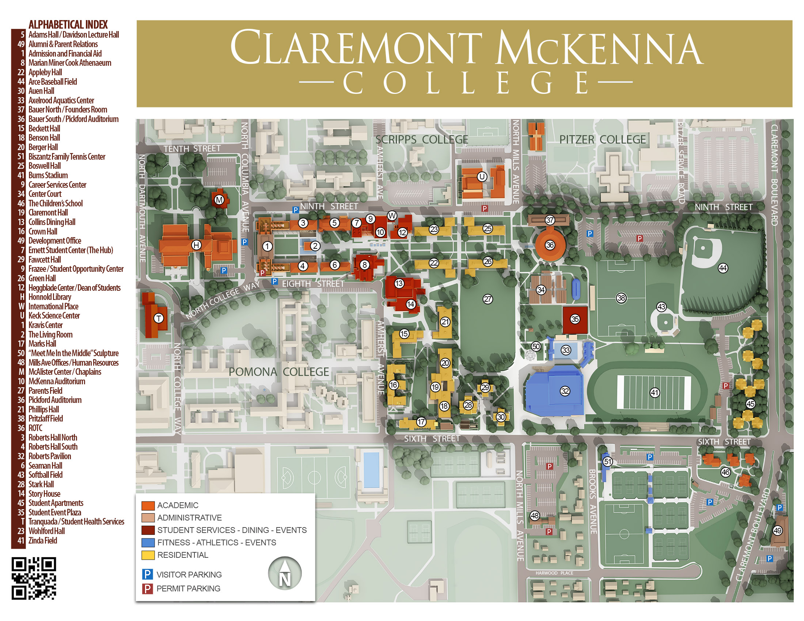

# Employee Materials

* Employee ID
  + Go to Connects in The Claremont Colleges Library Honnold Mudd (H on map, page 4)
    - Take picture
    - Receive ID
  + Go to Story House (14 on map, page 4)
    - Get access to infrastructure (doors)
    - Also need a KEY for office room
* Email and Username
  + Setup appointment for IT (Jeff)
    - [Jeffrey.Ng@claremontmckenna.edu](mailto:Jeffrey.Ng@claremontmckenna.edu) ([jng@cmc.edu](mailto:jng@cmc.edu)) or [help@cmc.edu](mailto:help@cmc.edu)
  + Obtain computer access
  + Get put into system
* Kronos
  + Send email to Payroll
    - [payroll@cmc.edu](mailto:payroll@cmc.edu)
  + Find Kronos in Workday
  + Log in hours
    - Talk to Janna
* Health Documents
  + <https://www.cmc.edu/healthscreen>

# Accounts and Software

* CMC Self-Service Account Management
  + <https://mypassword.claremontmckenna.edu/showLogin.cc>
* CMC Email
  + <https://cmc.edu/mail/office365>
    - CMC e-mail address: firstname.lastname@claremontmckenna.edu
    - Short-hand: firstthreelettersofyourfirstnameandwholelastname@cmc.edu
* Dashboards Events
  + <https://events.cmc.edu/newemployeeusername/home>
* GitHub
  + <https://github.com/CMC-QCL>
* Workday
  + <https://www.myworkday.com/theclaremontcolleges/d/home.htmld> (refer to page 3)
  + Kronos (in here)
* QCL Home page
  + [cmc.edu/login](http://cmc.edu/login)
  + <https://www.cmc.edu/qcl>
* Box
  + <https://claremontmckenna.account.box.com/login?redirect_url=%2Ffolder%2F0>
* Bit.ly
  + No account (you will use it a lot)
  + <https://bitly.com/>
* Qualtrics
  + <https://qfreeaccountssjc1.az1.qualtrics.com/login?path=%2FQ%2FMyProjectsSection&product=project-store-proxy>
* Localist
  + <https://events.cmc.edu/admin>
* Zoom
  + <https://cmc-its.zoom.us>
* Teams
  + Make sure to download desktop version and mobile as well
  + <https://teams.microsoft.com>
* Issues?[2]

# Logins and Passwords[3]

|  |  |  |
| --- | --- | --- |
| Accounts | Username | Password |
| CMC Self-Service Account Management |  |  |
| CMC Email |  |  |
| Dashboards Events |  |  |
| GitHub |  |  |
| Workday |  |  |
| QCL Home page |  |  |
| Box |  |  |
| Bit.ly |  |  |
| Qualtrics |  |  |
| Localist |  |  |
| Zoom |  |  |
| Teams |  |  |

# Schedule

Important Dates

* Team meetings
  + Biweekly: Wednesdays 10am -11am
* Graduate Fellow meetings
  + Talk to Dr. Park to set up best time
  + Current Fellow meeting: 9:30am-10am
  + New Time: _______________________
* Workshops
  + Wednesdays 3pm-5pm or 4pm-6pm
  + Fridays 9am-11am or 10am-12pm
* Staff days
  + Janna will send out email
* Employees Schedule (20 hours a week)
  + Talk to Dr. Park

|  |  |  |  |  |
| --- | --- | --- | --- | --- |
| Monday | Tuesday | Wednesday | Thursday | Friday |
|  | Current Fellow meeting:  9:30am-10am | Biweekly Team  meeting:  10am -11am  Workshop:  3pm-5pm or  4pm-6pm |  | Workshop:  9am-11am or 10am-12pm |

# Graduate Fellows Meeting

* BOX
  + Titled: QCL Fellows Meeting Agenda
  + <https://claremontmckenna.app.box.com/folder/0>

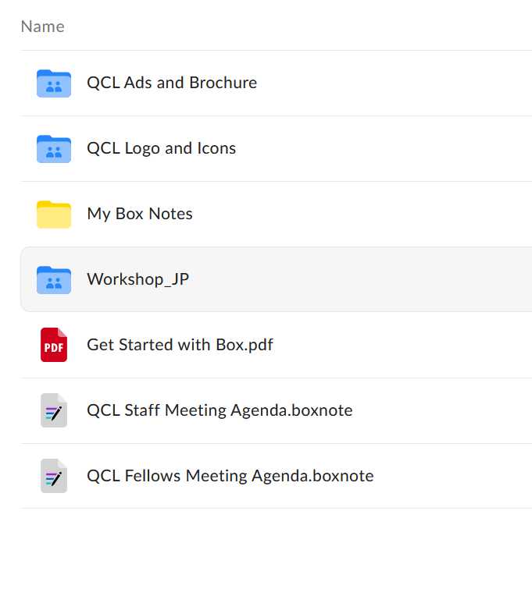

* Agenda
  + Write meeting notes
    - Before meeting
      * Let Dr. Park write minutes unless he asks you
  + Follow along in the meeting
  + TO DOs
    - Your assignments for the week

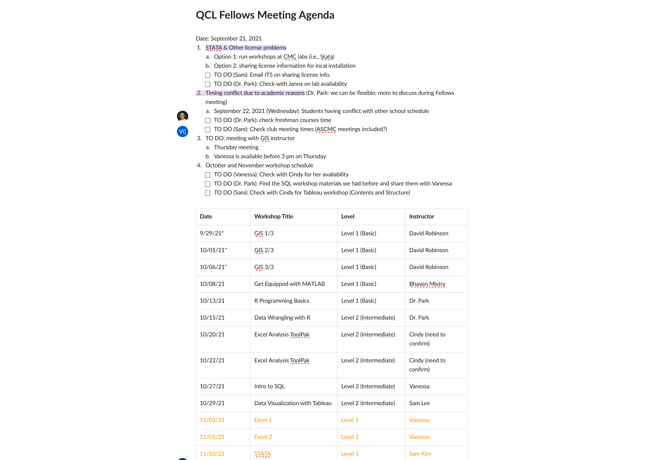

# Editing the QCL-CMC Website

* Every week, we update [cmc.edu/qcl/qcl-workshop](http://cmc.edu/qcl/qcl-workshop) page, whenever we open or close registration + update our schedule
* In terms of website access:  
  1) Log in at [cmc.edu/login](http://cmc.edu/login)  
  2) Go to [cmc.edu/qcl](http://cmc.edu/qcl)  
  3) See “View,” “Edit,” and “Revisions” tabs right above body

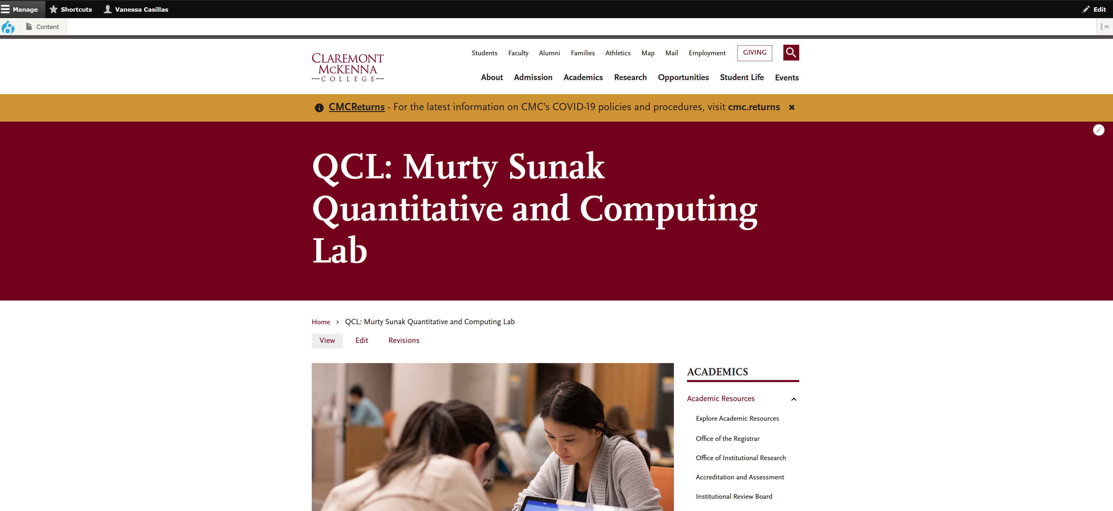

# Workshops

## Start of Semester

* Topics
  + Pick
  + Dr. Park in Fellows meeting
* Dates
  + Assign
  + Dr. Park in Fellows meeting
* Instructors
  + Assign
  + Dr. Park in Fellows meeting

## Workflow

### Two weeks before day of workshop

* Contact Instructor
  + Setup meeting
    - Agenda of meeting
    - Summary of localist
    - Software
    - Websites
    - Licenses

#### Instructors Notes turned into Summaries

**[QCL Workshop] Title**

About this Event

# Title

## Summary

## Agenda:

# Learning Objectives: (You will learn how to)

# Prerequisites

## Location

## Participants

#### Instructors Notes turned into Summaries example

**[QCL Workshop] R Programming Basics (Level 1 – Coding)**

About this Event

# R Programming Basics (Level 1 - Coding)

## Summary

R is an open-source statistical programming language. R is widely used in industry as well as in academia for statistical analysis and data visualization. In this workshop, we introduce the basics of the R language and its programming environment through simple hands-on examples.

This workshop is designed for beginners in R programming, so no prior knowledge of R programming is needed. However, general programming knowledge in any programming language will be help understand the programming concepts.

**We will be using RStudio Cloud for hands-on. Please create a free account at** [**https://rstudio.cloud**](https://rstudio.cloud)**before join the workshop.**

## Agenda:

* Basics of R and RStudio
* R Programming Environment: Workspace, Working Directory, Package
* R objects (data structure and function)
* R packages for data import and export
* R graphics for simple plotting methods
* Basic statistical analysis using R

## Location

Hybrid (In-person: QCL Classroom, Online: Zoom information will be provided to the attendees after registration)

Click [here](https://www.cmc.edu/qcl/qcl-location) to find your way to the QCL.

## Participants

CMC Students, Faculty, and Staff

# Data Wrangling with R (Level 2 - Data)

## Summary  
Data wrangling is the process of obtaining, cleaning, reshaping, and transforming raw (and messy) data into a useable form of processed (and tidy) data. It is known that a majority of data analysts and data scientists spend as much as 80% of their time on data wrangling. So it's essential to get familiar with good data wrangling tools that help you save time and avoid errors. In this hands-on workshop, you will learn basic skills to import, export, clean, reshape, transform, and visualize data using well-known data science package called tidyverse.

# Learning Objectives: (You will learn how to)  
Import and export data  
Clean, reshape and transform data  
Make messy data into tidy data  
Visualize tidy data using ggplot2 (if time permits)

# Prerequisites  
Basic knowledge of R and RStudio (e.g., R Programming for Beginners - Level 1)  
RStudio Cloud account; if you don't have one yet, please create a new account from <https://rstudio.cloud> site.  
Tidyverse package; please make sure that you have installed the tidyverse package in your R environment. See <https://www.tidyverse.org> for more information.

## Location

Hybrid (In-person: QCL Classroom, Online: Zoom information will be provided to the attendees after registration)

Click [here](https://www.cmc.edu/qcl/qcl-location) to find your way to the QCL.

## Participants  
CMC Students, Faculty, and Staff

**### GIS - Part 2 (Level 1 - Data) Workshop**

About this Event

## Summary

This workshop will introduce you to the ever-expanding and fascinating world of geographic information systems (GIS). In three 2-hour sessions you will learn about what GIS is, how it is used in a multitude of industries and fields, and how to get started using GIS software. We will examine GIS concepts and software tools used to visualize real-world features, discover patterns, and communicate information. Primarily using ArcGIS Online (if you can hyperlink: <https://doc.arcgis.com/en/arcgis-online/get-started/what-is-agol.htm>) you will work with GIS maps, explore data, and analyze maps and data as you learn fundamental concepts that underlie GIS technology.

Through a series of presentations, in-class tutorials, and homework assignments this workshop will give you a strong beginning foundation on how to make maps and explore spatial data to identify patterns and insights in your data you never knew possible. You will come away from this workshop with the understanding you need to start working with GIS and utilize it in your own work and explorations. You do not need any previous experience – just your own curiosity!

Students in this workshop (in fact, all Claremont Colleges students) have free access to a wide variety Esri GIS products. For more information, check out the Claremont Colleges Library Geographic Information System (GIS) Services home page, <https://library.claremont.edu/gis/>

## Learning Objectives: (You will learn how to)

Topics will include:

* Introduction to the GIS Platform
* Theoretical basis of GIS and the Geographic Approach
* What can you do with GIS?
* Understanding GIS data
* An introduction to Coordinate systems and Projections
* Acquiring and selecting GIS Data
* Utilizing and preparing your own data for GIS
* Creating maps – basic cartography, symbology
* The US Census and GIS
* Introductory Spatial Analysis
* Sharing results – physical maps and the world online maps

## Location

The following event will be conducted in a hybrid format:

* Virtual: Zoom
* In-Person: QCL Classroom

## Participants

7C Students, Faculty and Staff

### One week before day of workshop

#### Zoom

* + Go to meetings

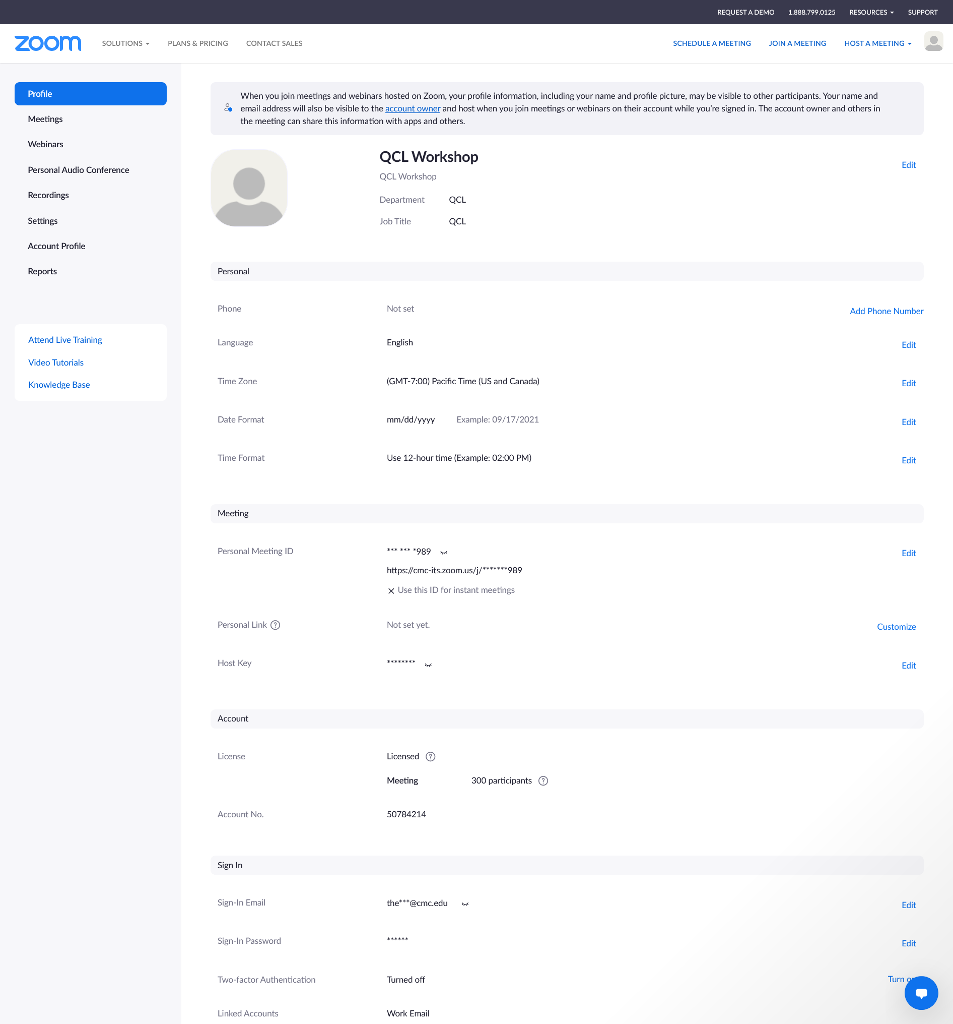

* + Click on Schedule a meeting 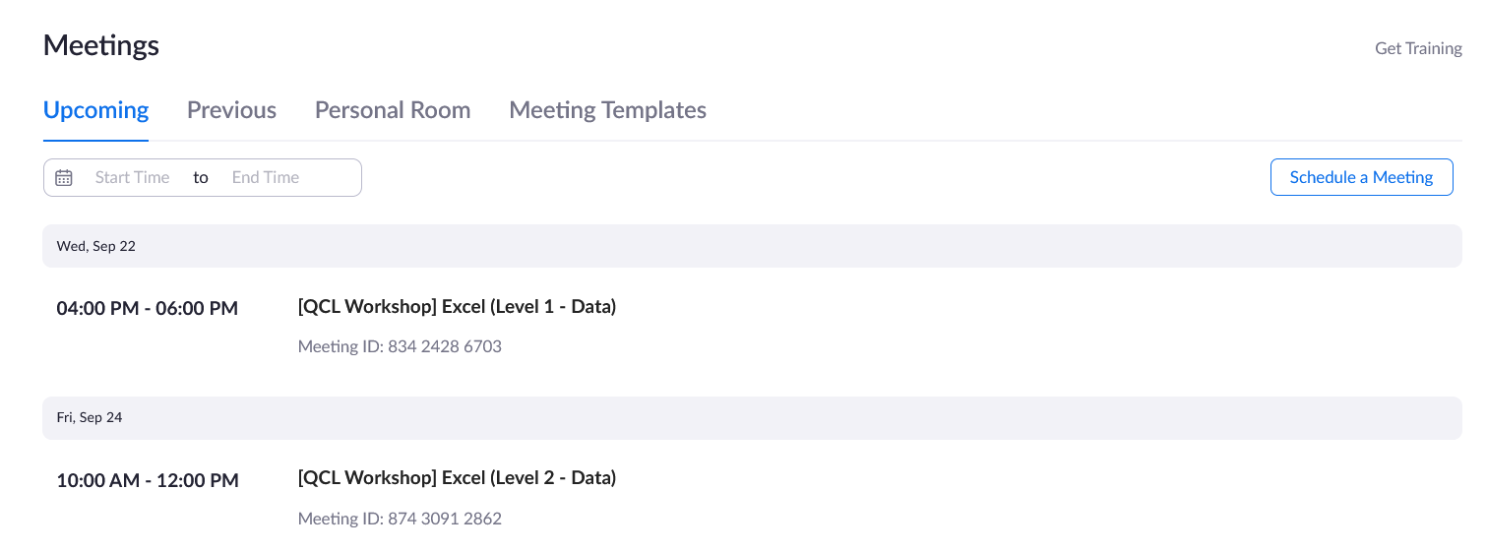
  + Go to QCL workshop schedule

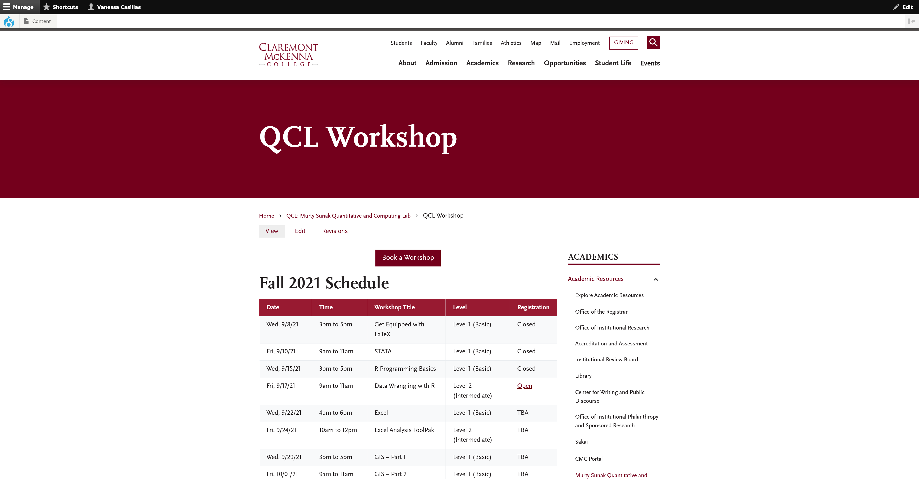

* + Look for workshop you are working on

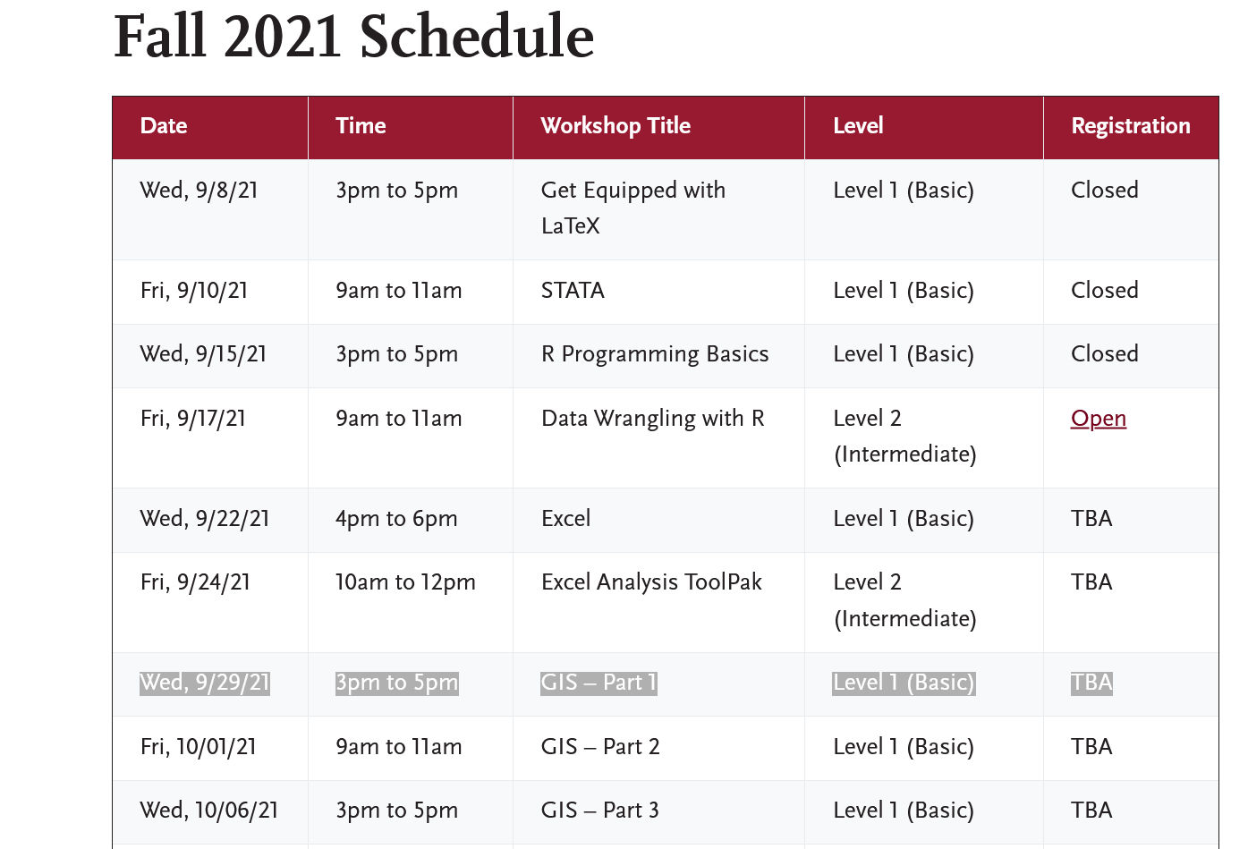

* + Fill in meeting information on Zoom then click save
    - Description (Optional) comes from Instructor’s meeting

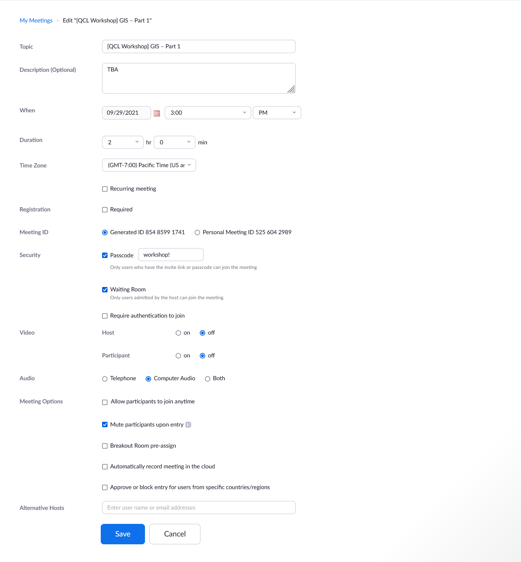

* + You will see this

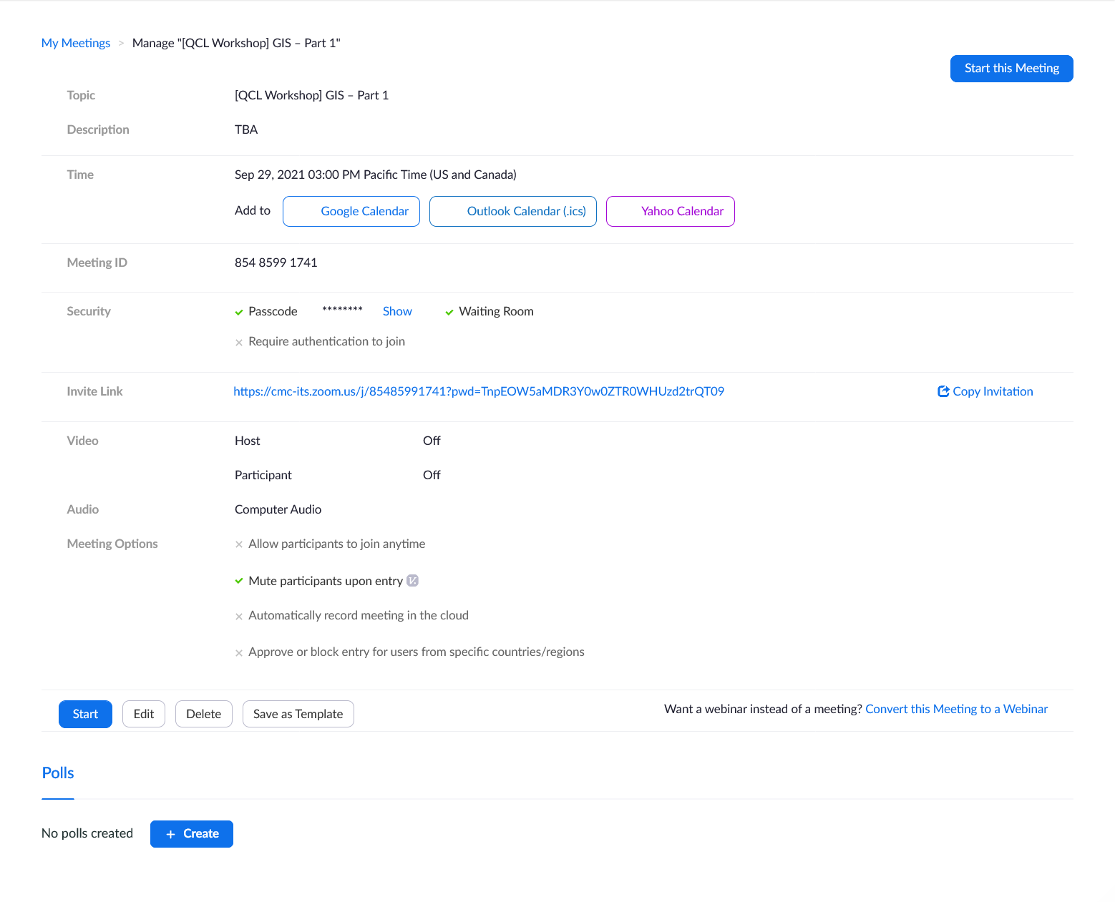

* + On meeting tab, it should there

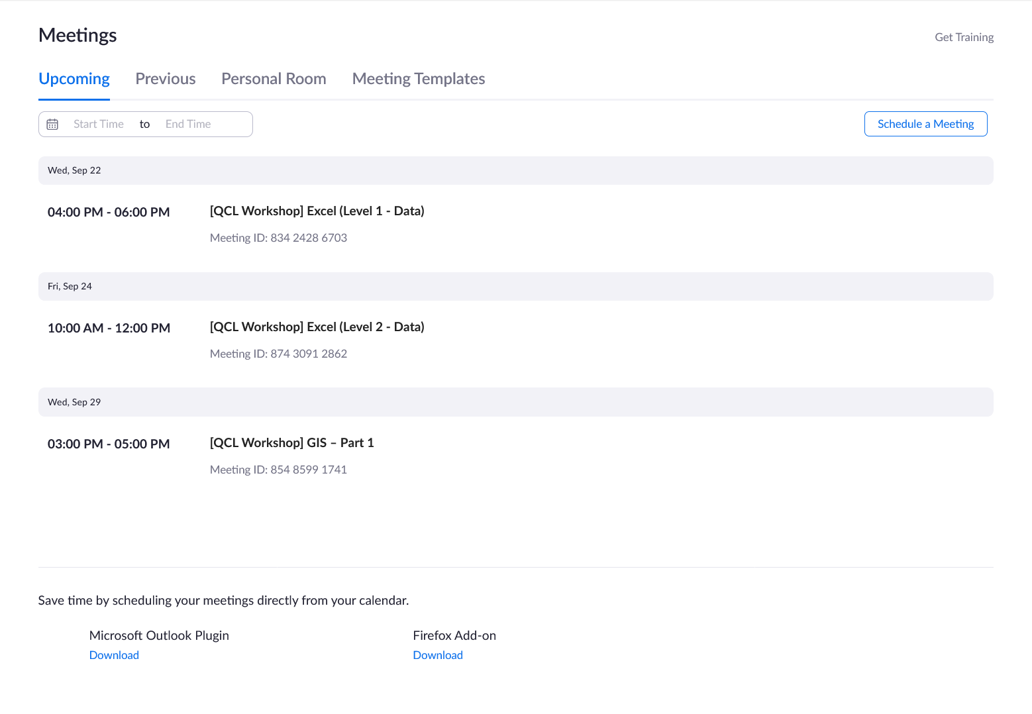

#### Localist

* + Start by copying an old event
    - Make sure you are working on copy
  + Fill in all information (Like below)
    - Click “Include Above in Schedule”
    - Delete the old Confirmed dates
    - Description is made from Instructor’s meeting

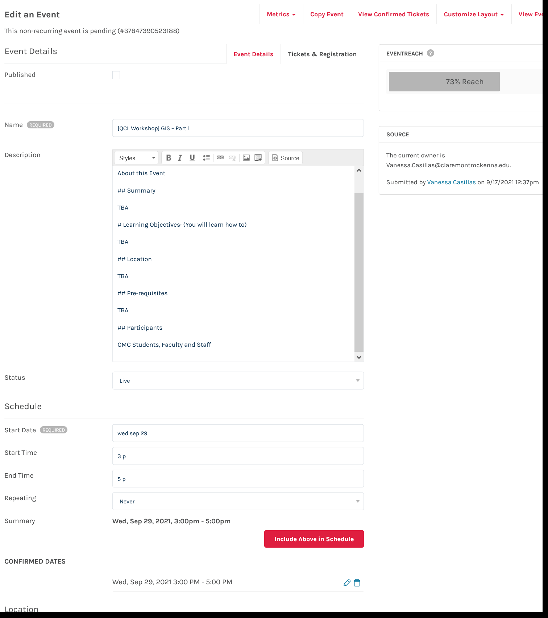

* + Fill out Location (Like below)
    - Check if event is only in-person, only virtual or hybrid

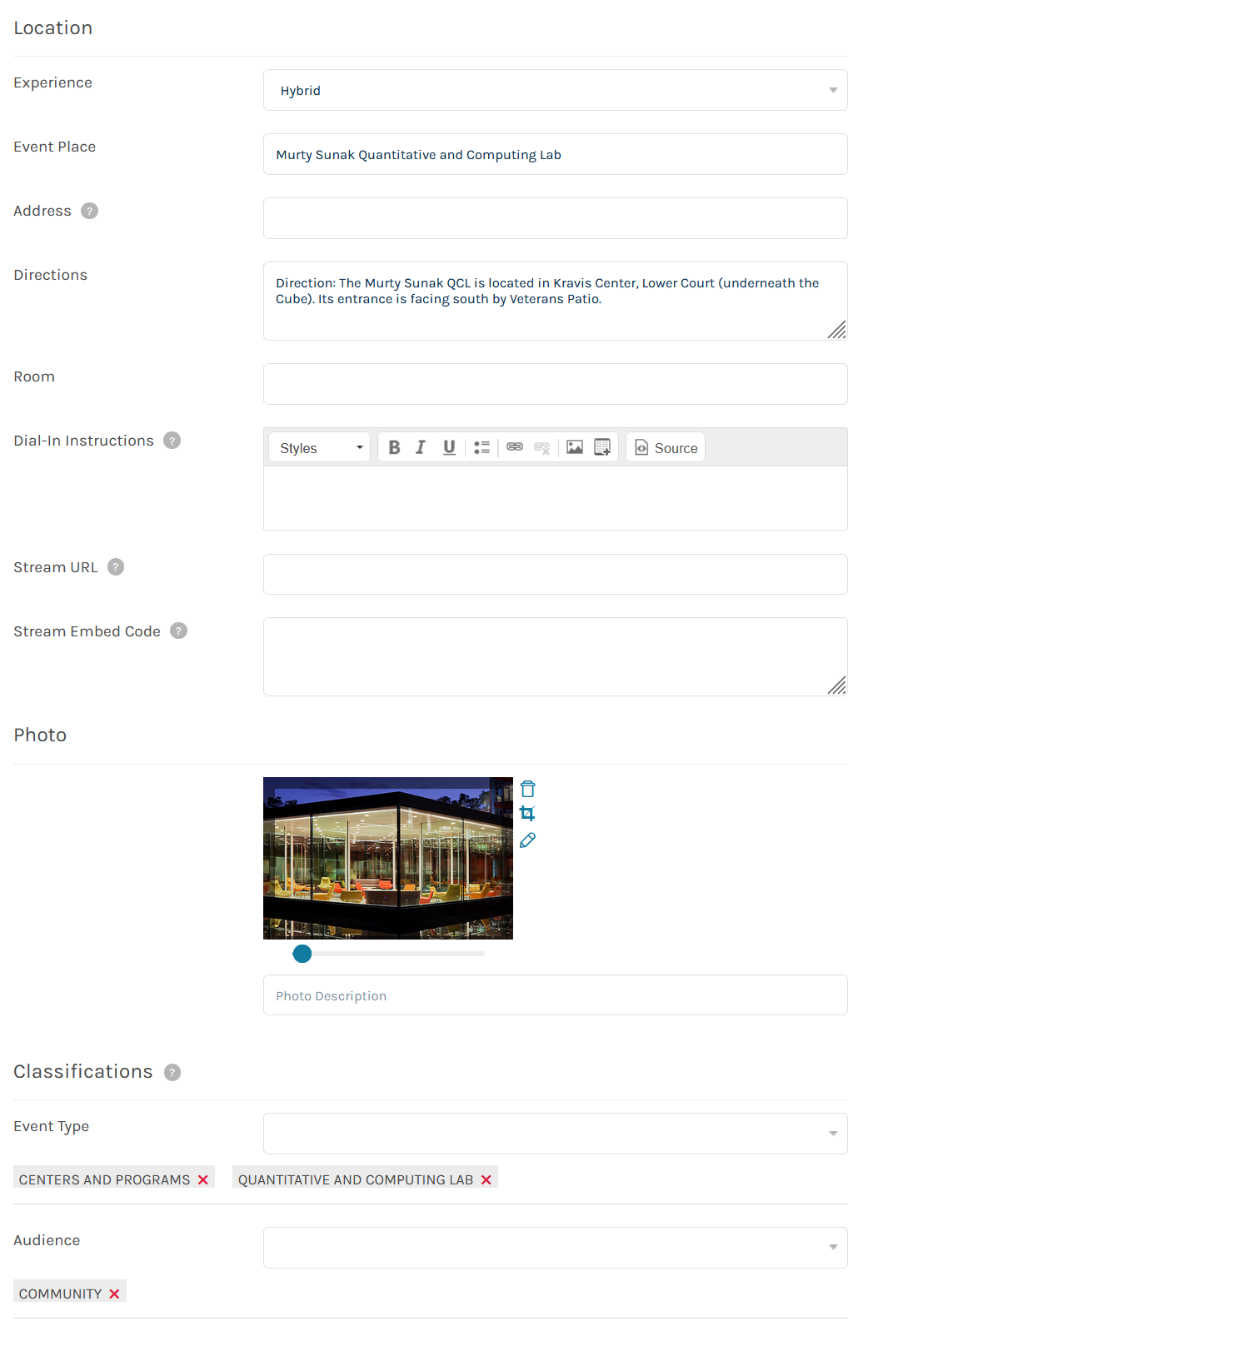

* + Change the Owner to yourself
    - Check Vanity URL

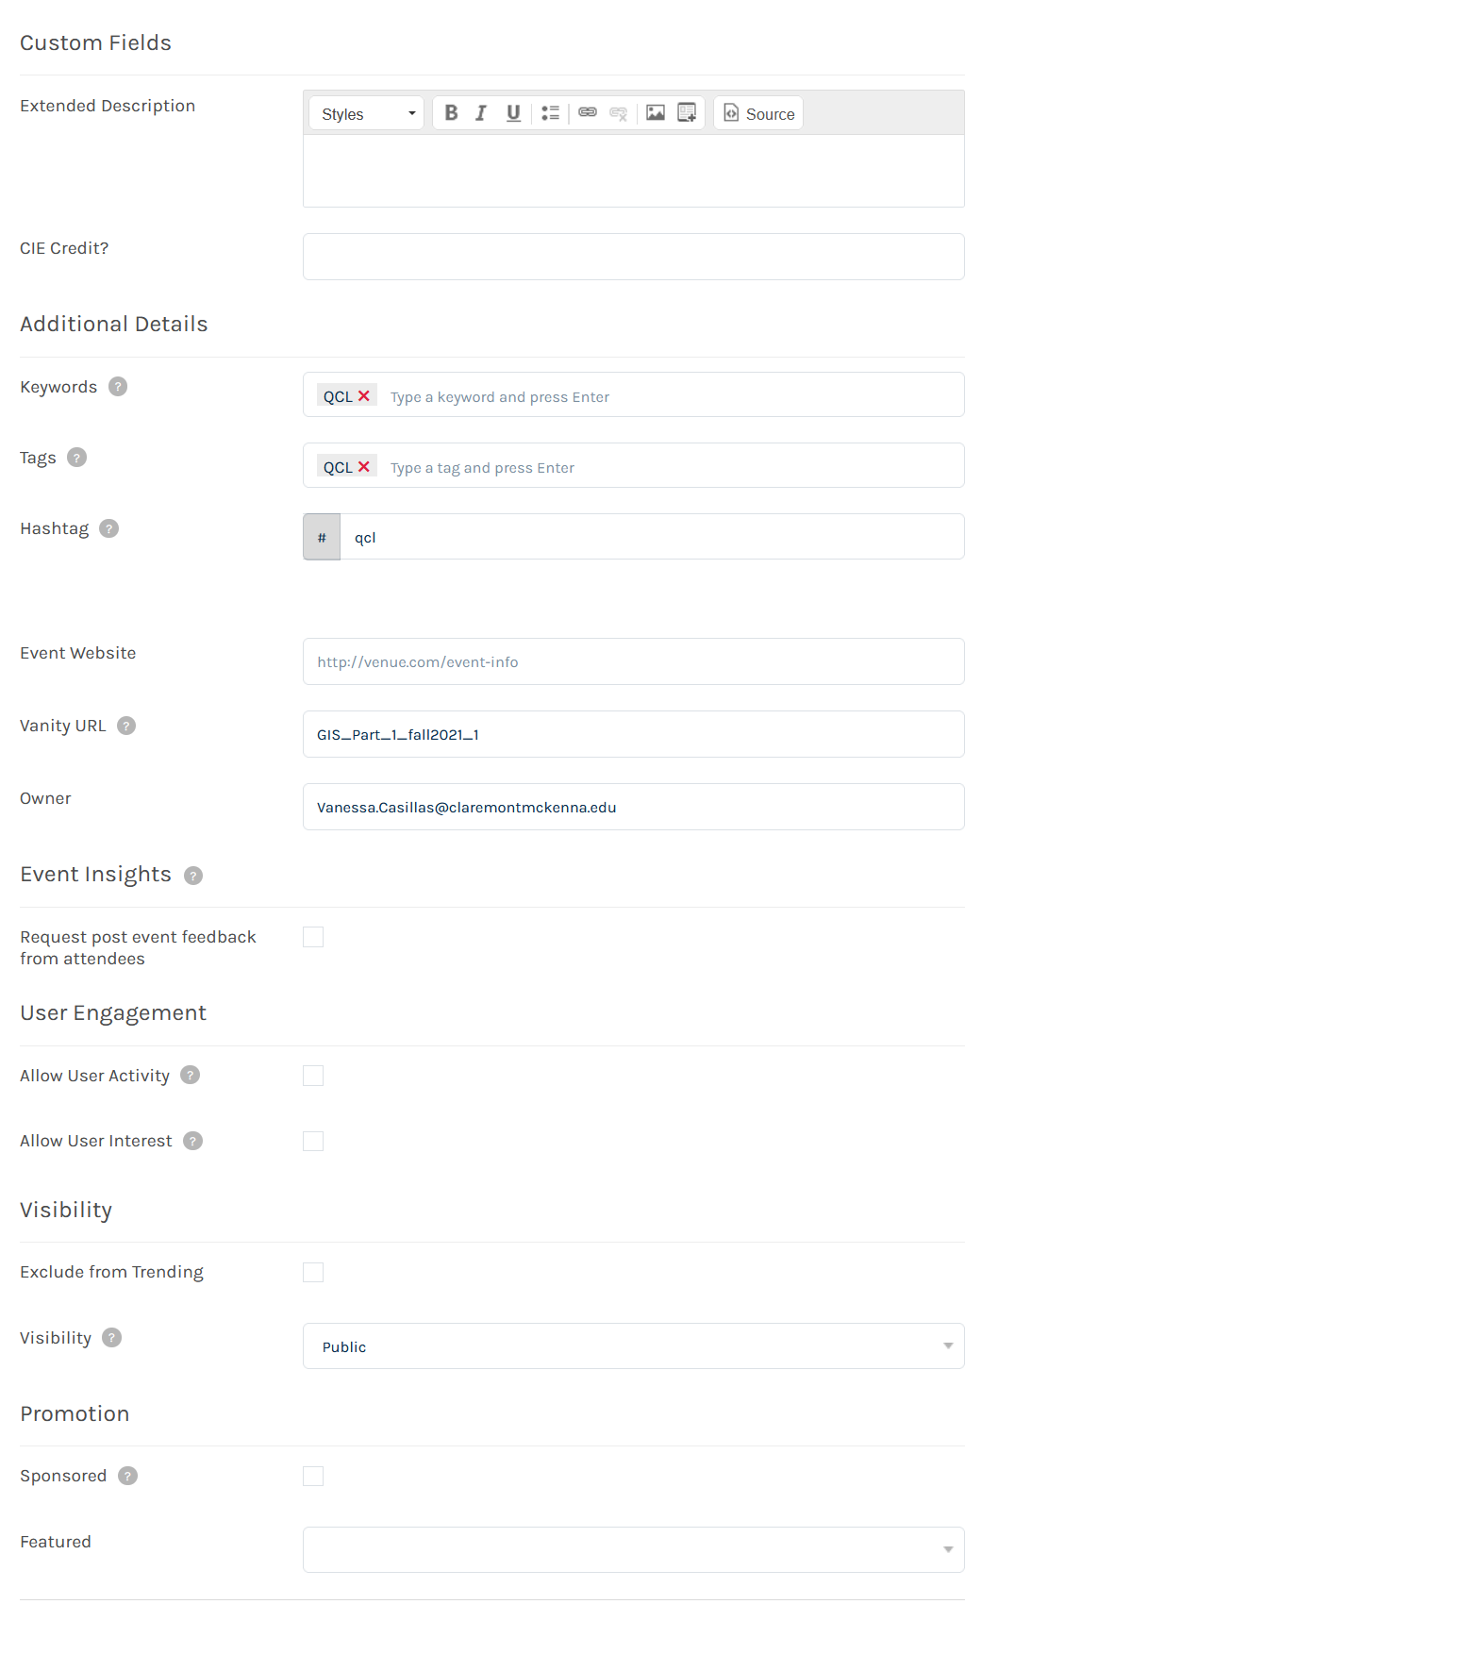

* Add a Ticket Types
  + Virtual or In-Person (or both)
  + Make sure Virtual is always on Top

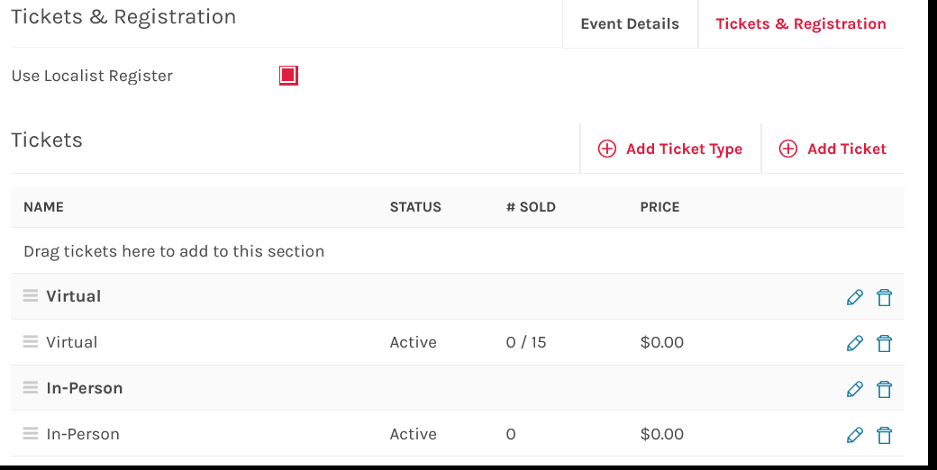

* Add a Virtual ticket name is ZOOM and drag to the right ticket type (pic wrong)
  + Then go into additional ticket options

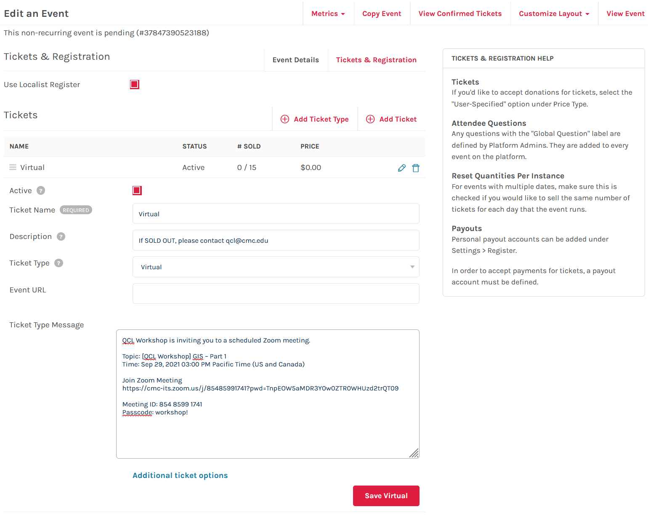

* Check to make sure settings are correct
* Make sure Ticket availability dates correctly dated or left blank if you will manual turn off

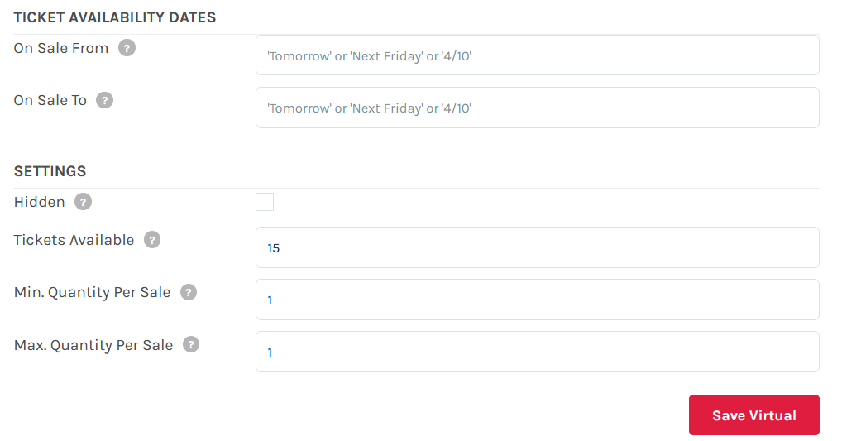

* Add in-person ticket named QCL CLASSROOM and drag to the right ticket type (pic wrong)
  + Then go into additional ticket options

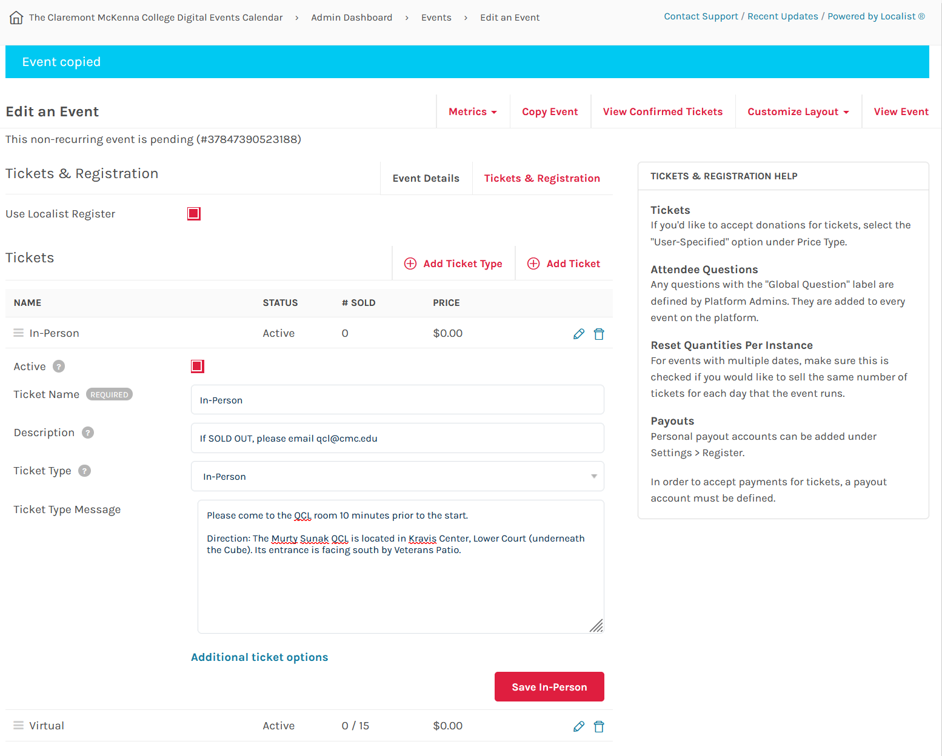

* Check to make sure setting are correct



* Check to make sure that Attendees Questions are correct

1. "Please enter your student ID # (Must be 8 characters). For all faculty/staff/non-Claremont Colleges person, please insert 00000000." (Required)
2. "Please indicate gender (male or female)"
3. "Which one of the Claremont Colleges are you from?" (Required)
4. "If not from the Claremont Colleges, where are you from?"
5. "Are you a Freshman, Sophomore, Junior, Senior, Graduate Student, Faculty, Staff or Other?" (Required)
6. "If Other, please specify:"

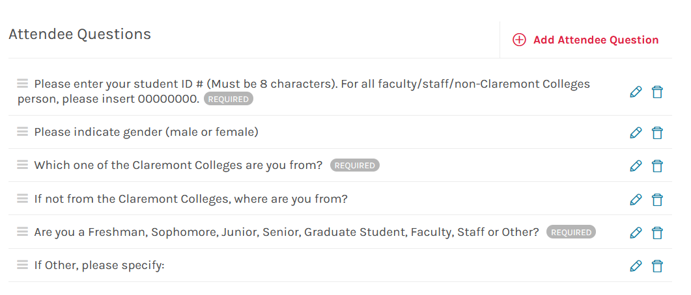

* Check to make sure you have the correct Event Capacity

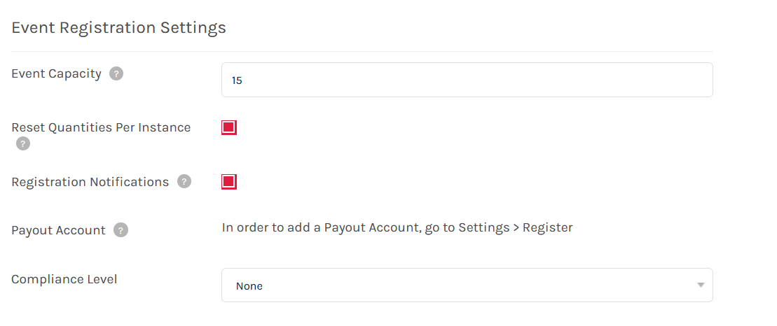

* Publish or NOT
  + Make sure if you are publishing that the checkmark is checked
  + But if you want another Fellow to review then make sure publish is not checked
  + Then Click Save
* TEST! TEST! TEST!
  + when you set up the registration pages, please test them by registering for the workshops and see if everything works fine including the email confirmation, Zoom links, etc.
* Send Dr. Park an email + post a message on Teams so that I can announce them.

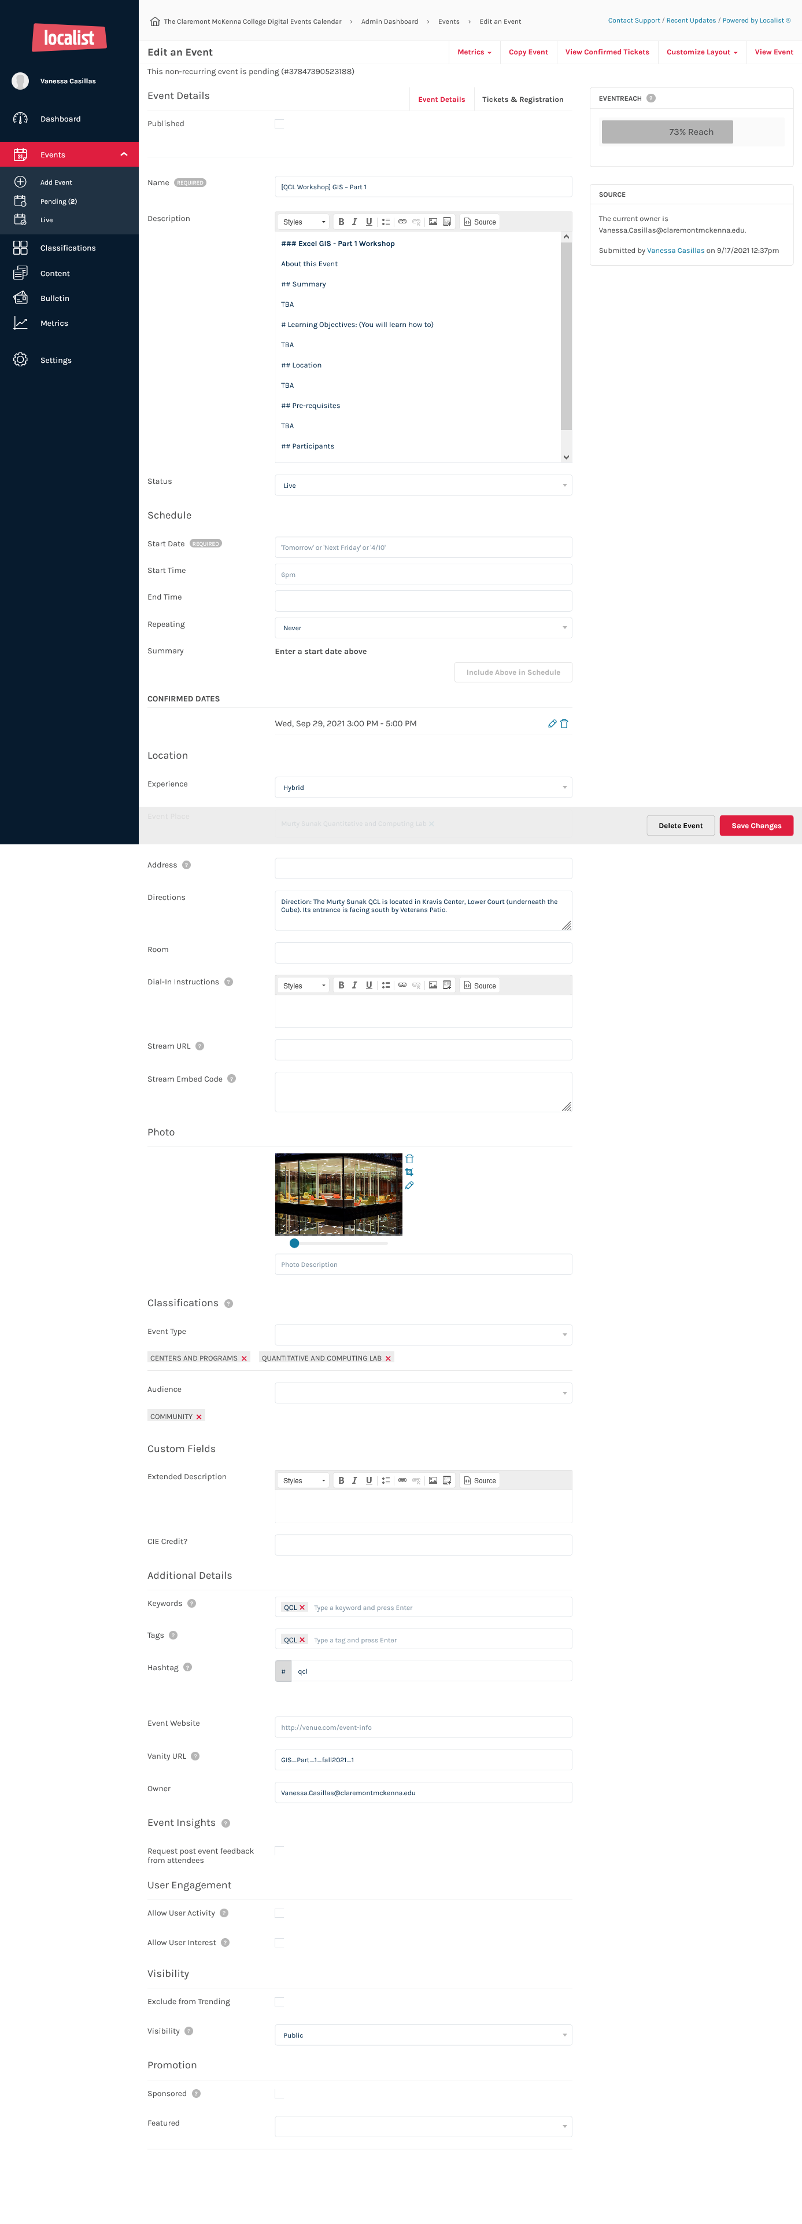

### Two days before day of workshop

#### Close Registration for workshop

* For those that do not require extensive prior prep, let’s close them 5 pm a day before. And, 2 days prior for those that require requesting licenses
  + Go into event
  + Go into tickets
  + Click inactivate on any tickets that are active

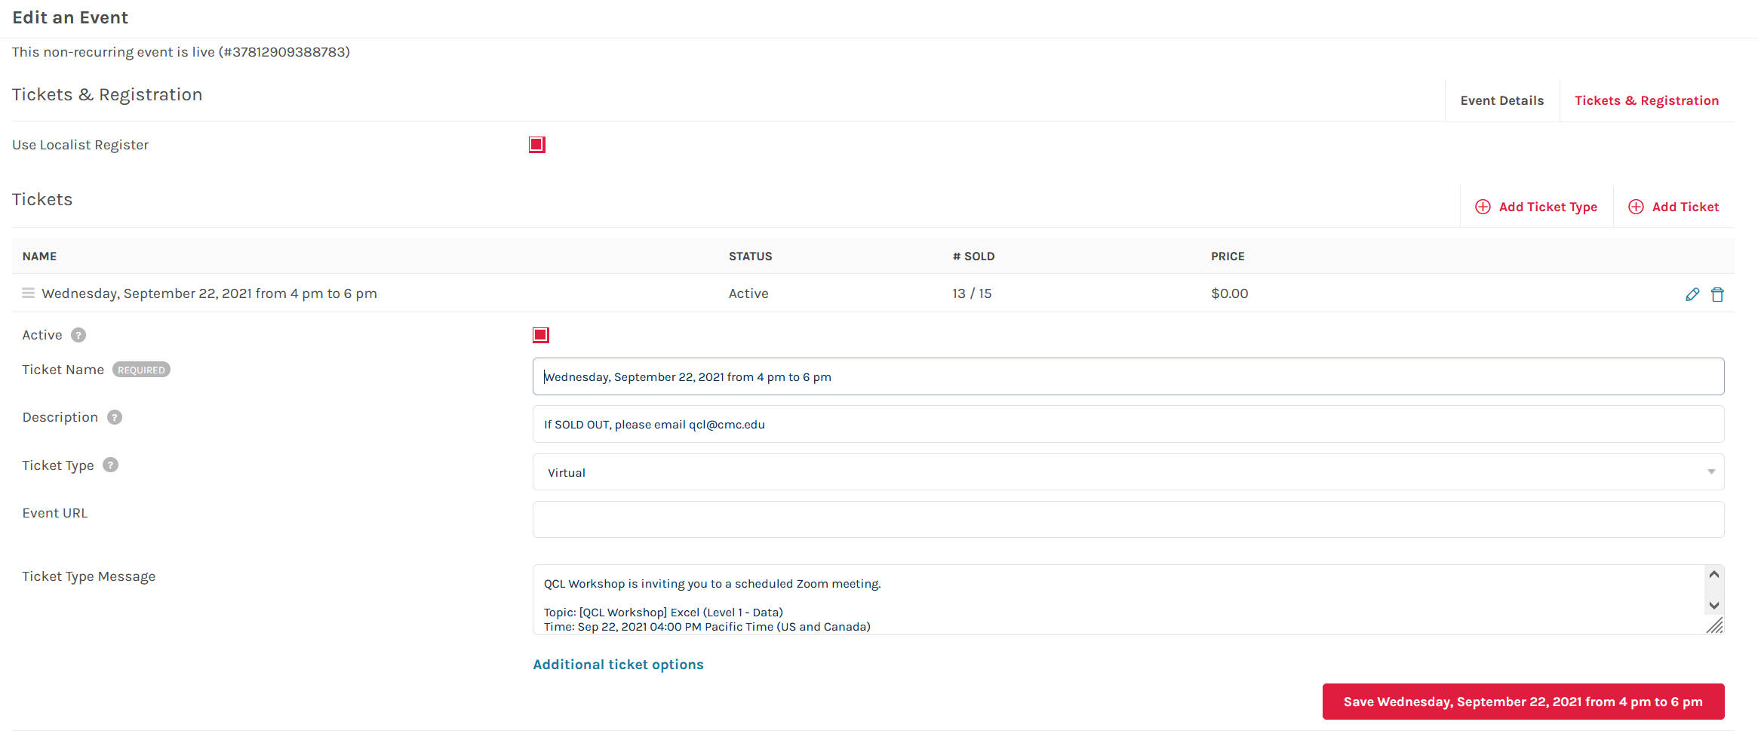

* You should see the ticket status as inactivate

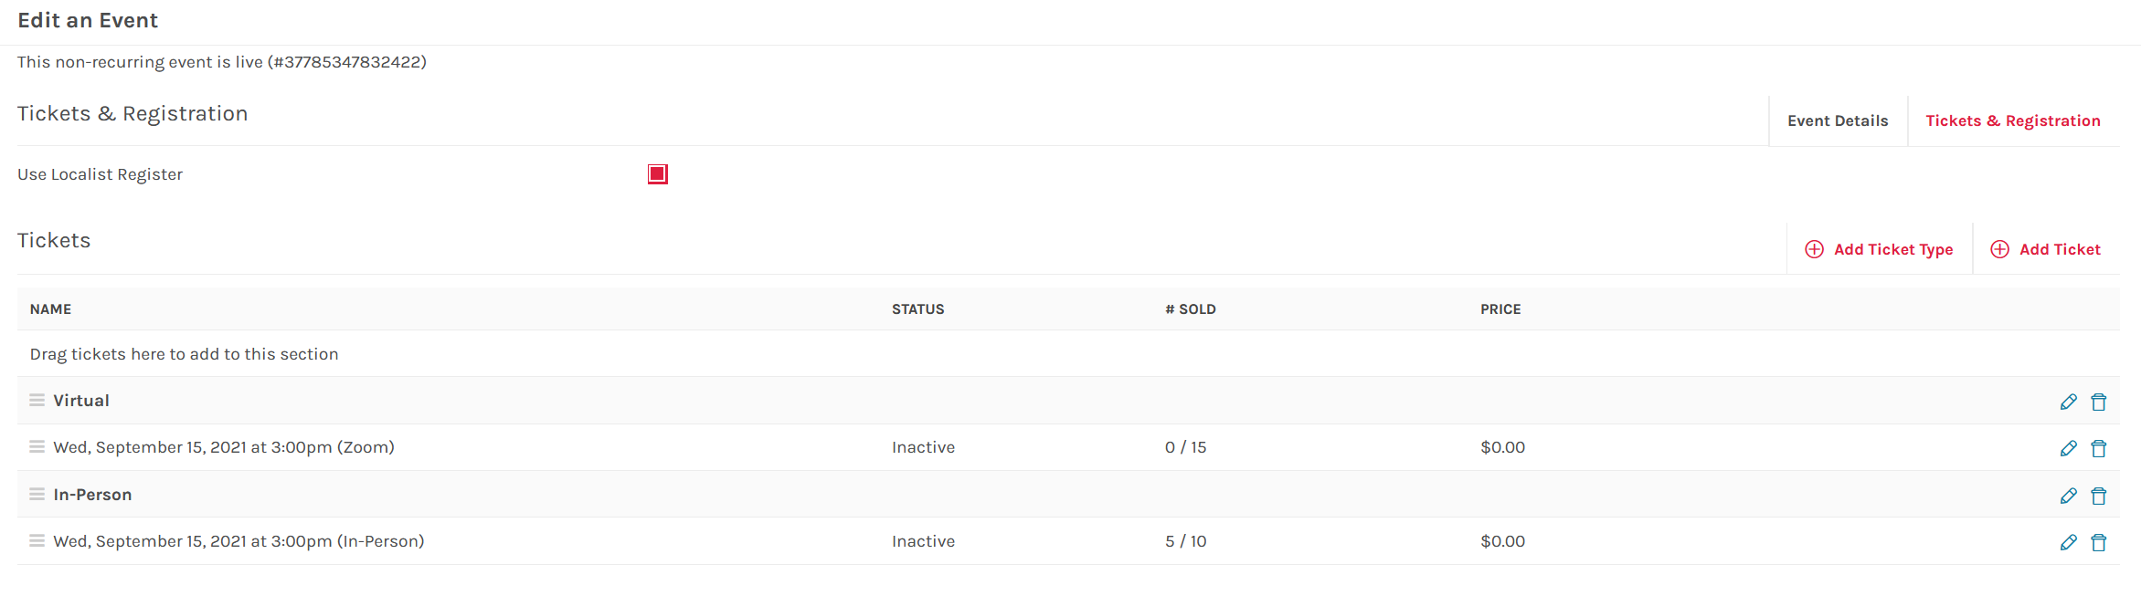

### Day before day of workshop

#### Qualtrics

* + Make sure to make a Sign and Exit one
    - Make copy of old one
      * Sign in for sign in
      * Exit for Exit

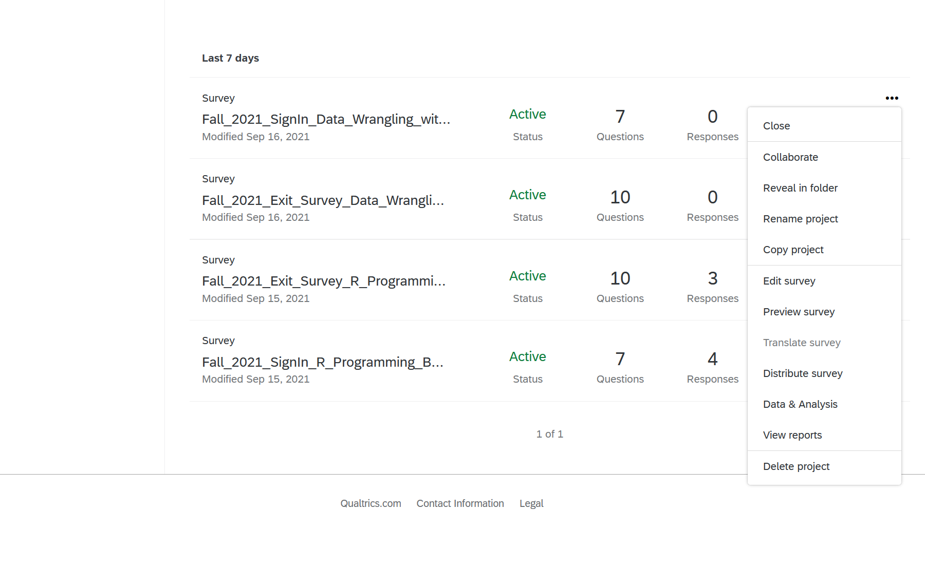

* + Change name to workshop name and instructor

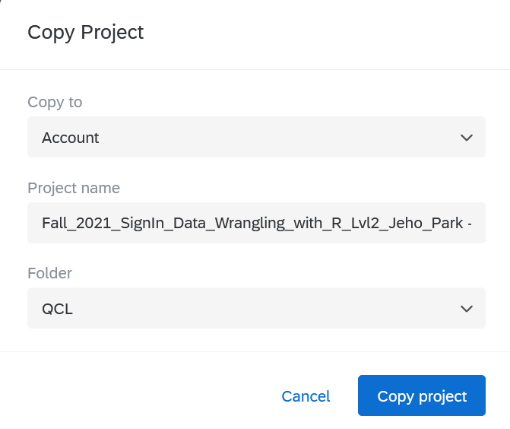

* + Change workshop sign-in for and Date/Time
    - Sign-in

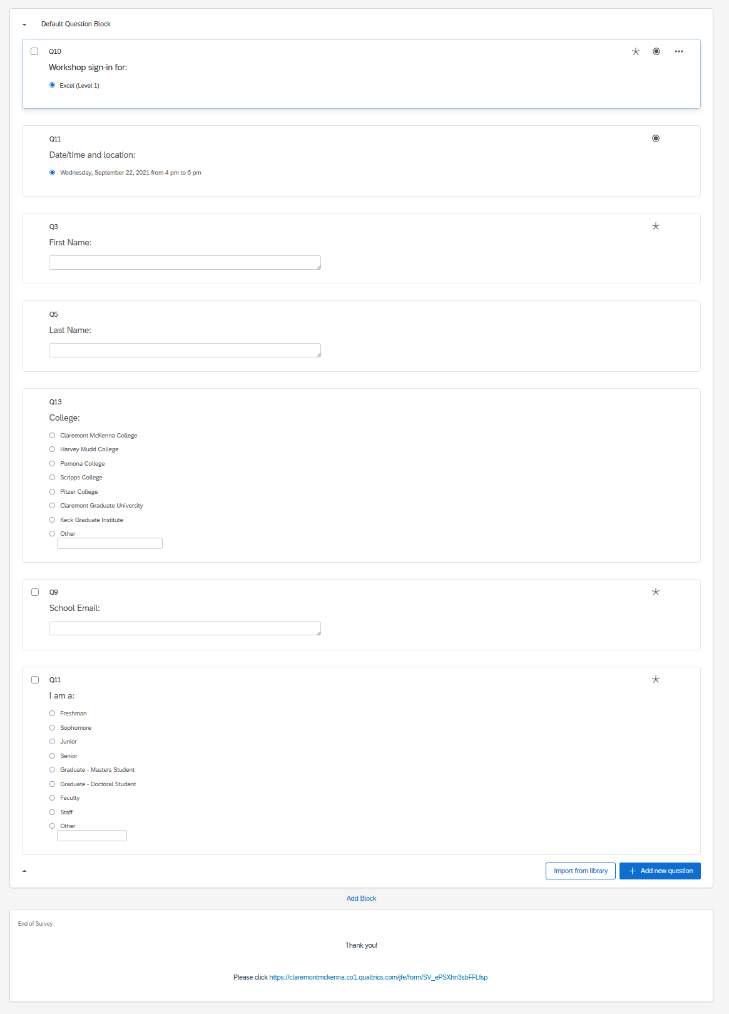­­

* + - Exit
      * Make sure to put full name and title for instructor

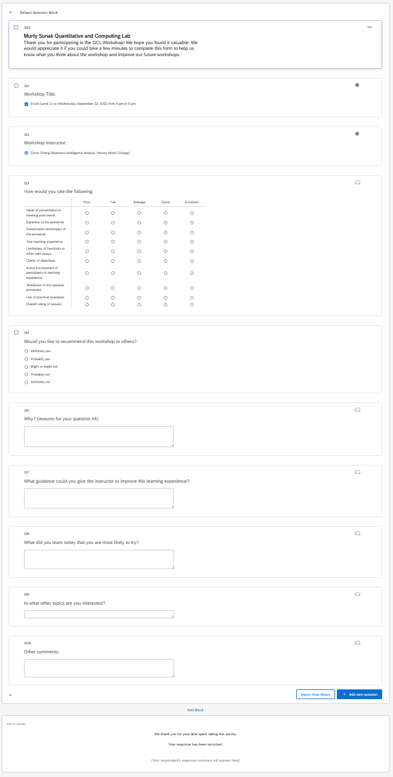

* + Click Publish

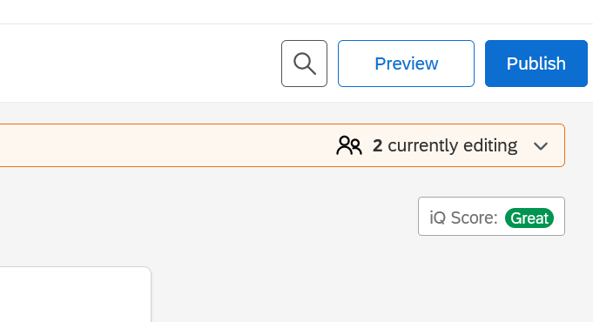

* + Copy link to use for Bit.ly later and hit publish
    - If you forget to get here, you can still get it when you make QR code

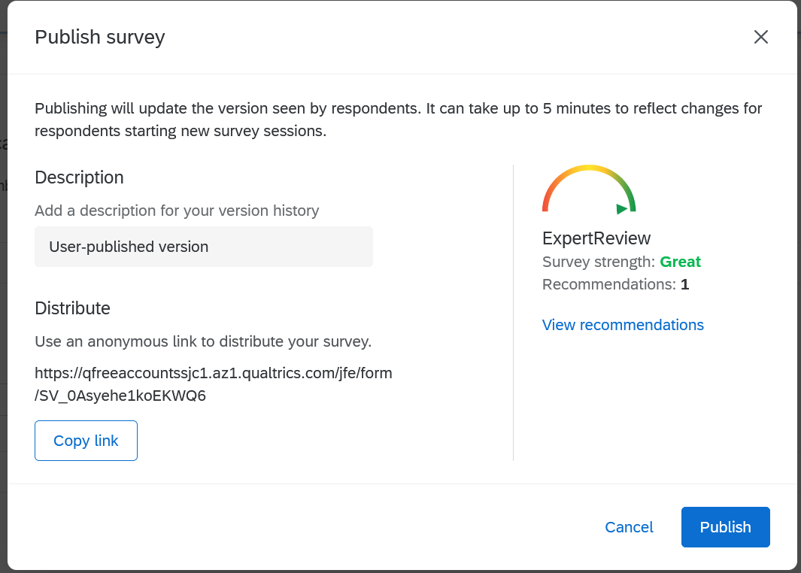

* + Barcode for Word doc
    - Anonymous link will give you the link of the survey again to put into Bit.ly
    - Download QR code for word doc use

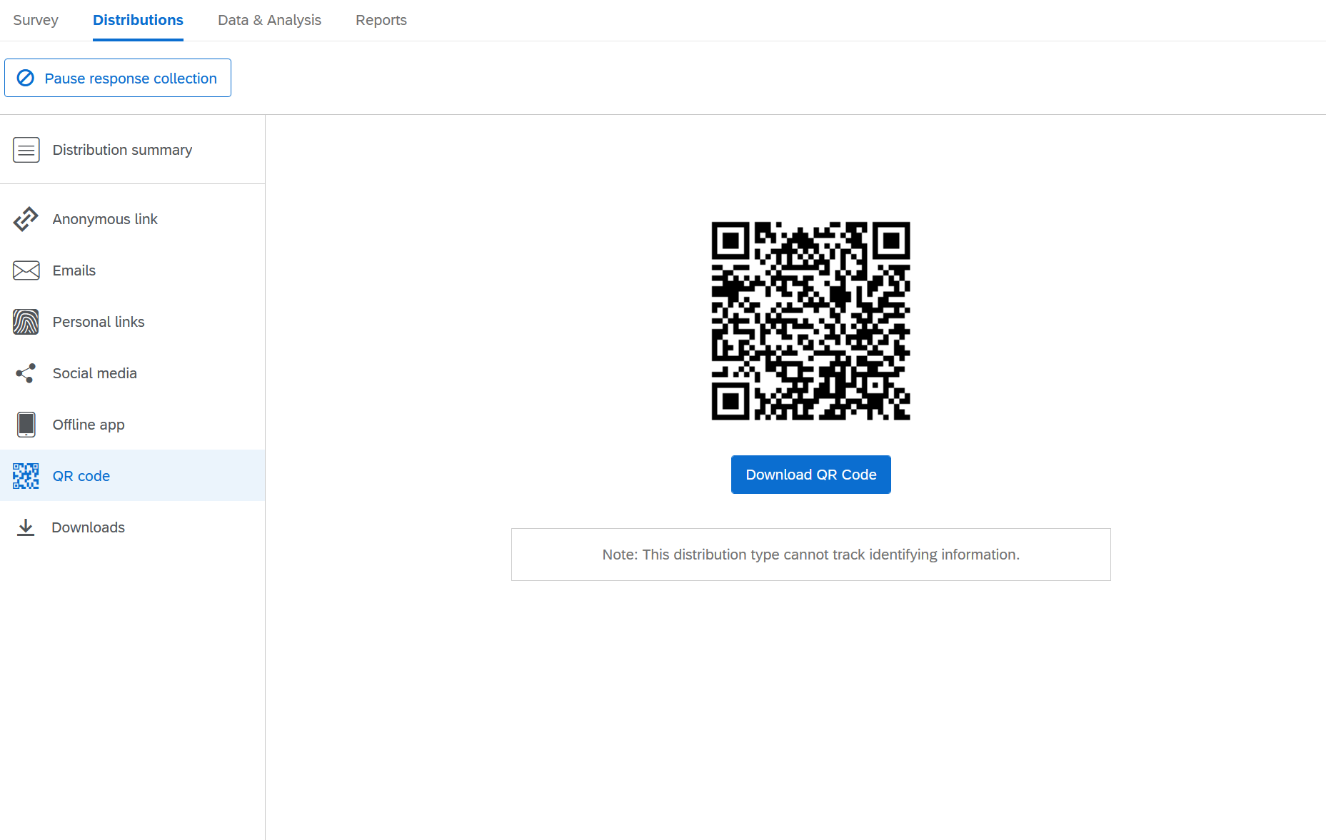

#### Bit.ly

* Copy and paste link from Survey into bar
  + - Click Shorten

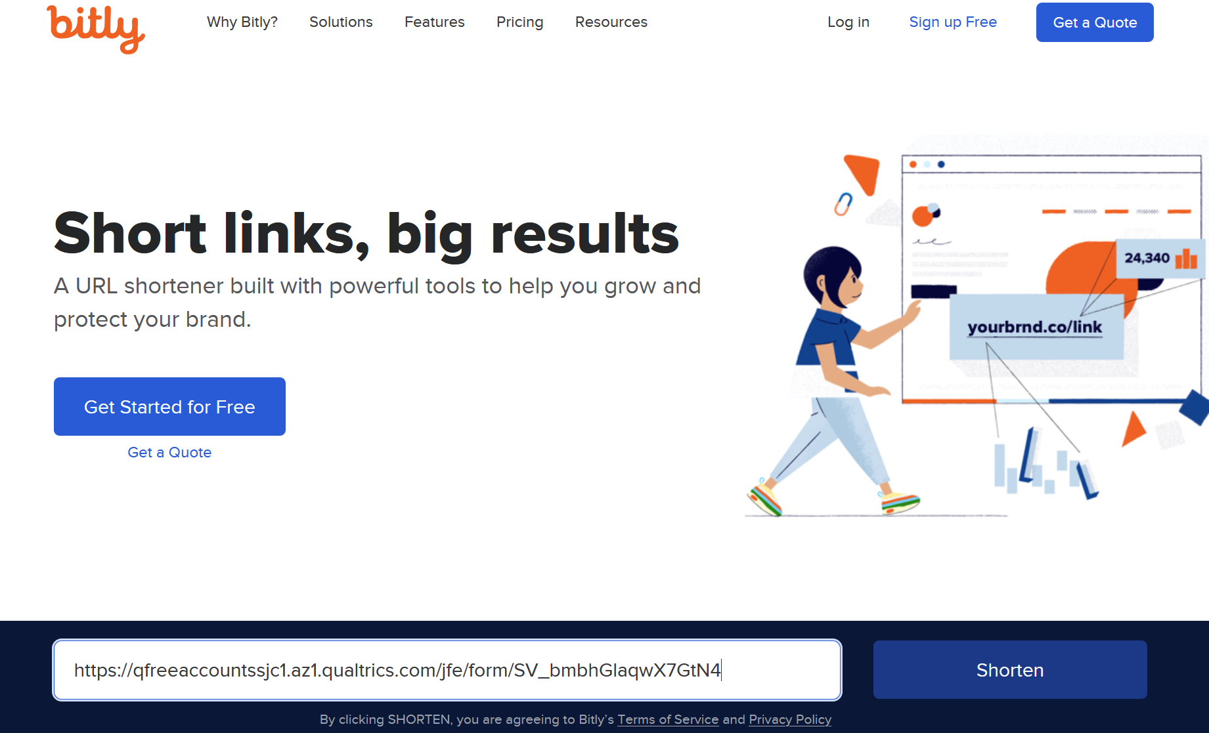

* Copy and paste the shorten link into word doc

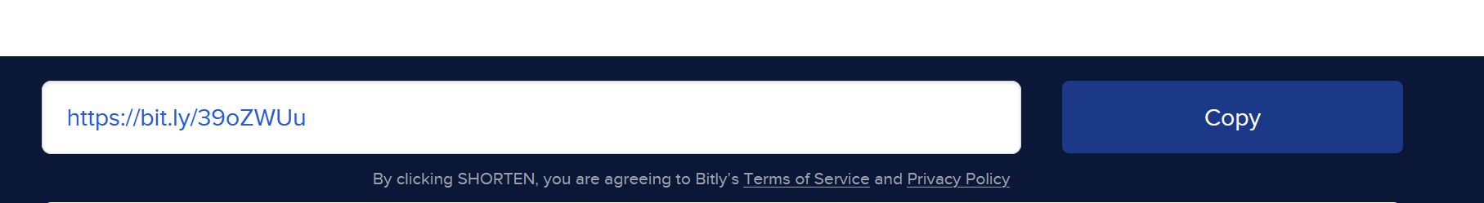

#### Flyer Word doc

* + Change to fit workshop
    - Title
    - Date & Time
    - Instructor
    - QR Code from Qualtrics
    - Shorten link from Bit.ly

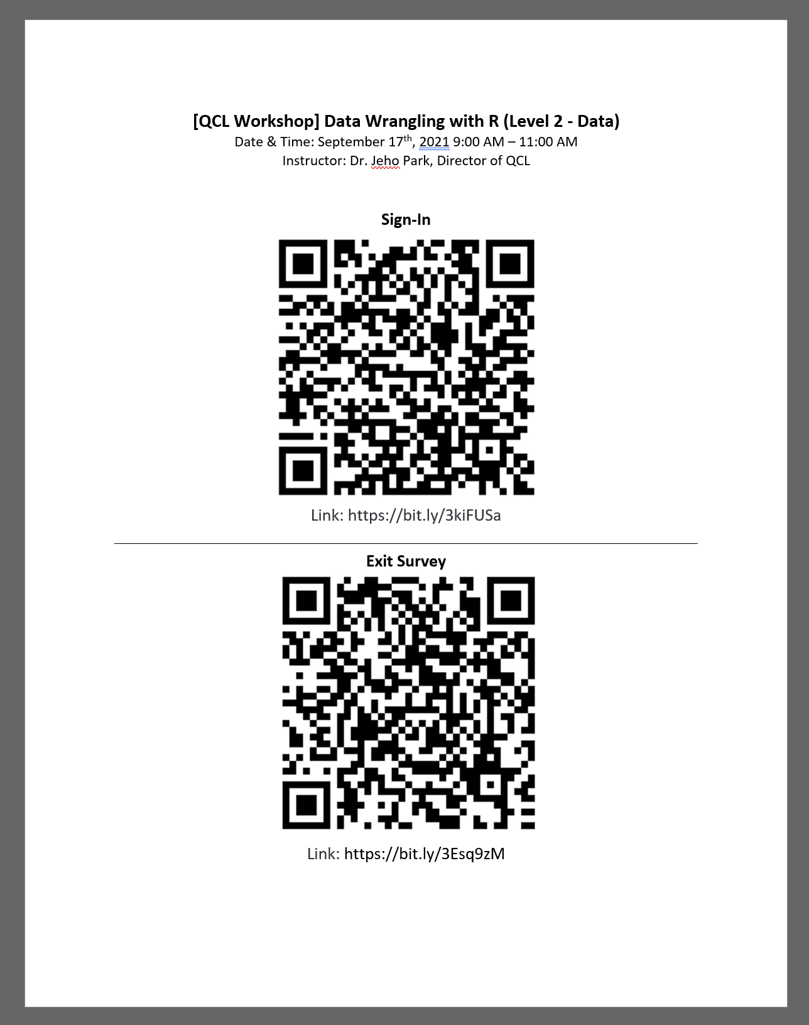

#### Emails (to be written)

#### Reminder Email

* send out a reminder email.
  + Add
    - Virtual Work info: Zoom invitation link (just in case)
    - In-Person Info:
    - Anything instructor wants to relay
      * Example 1

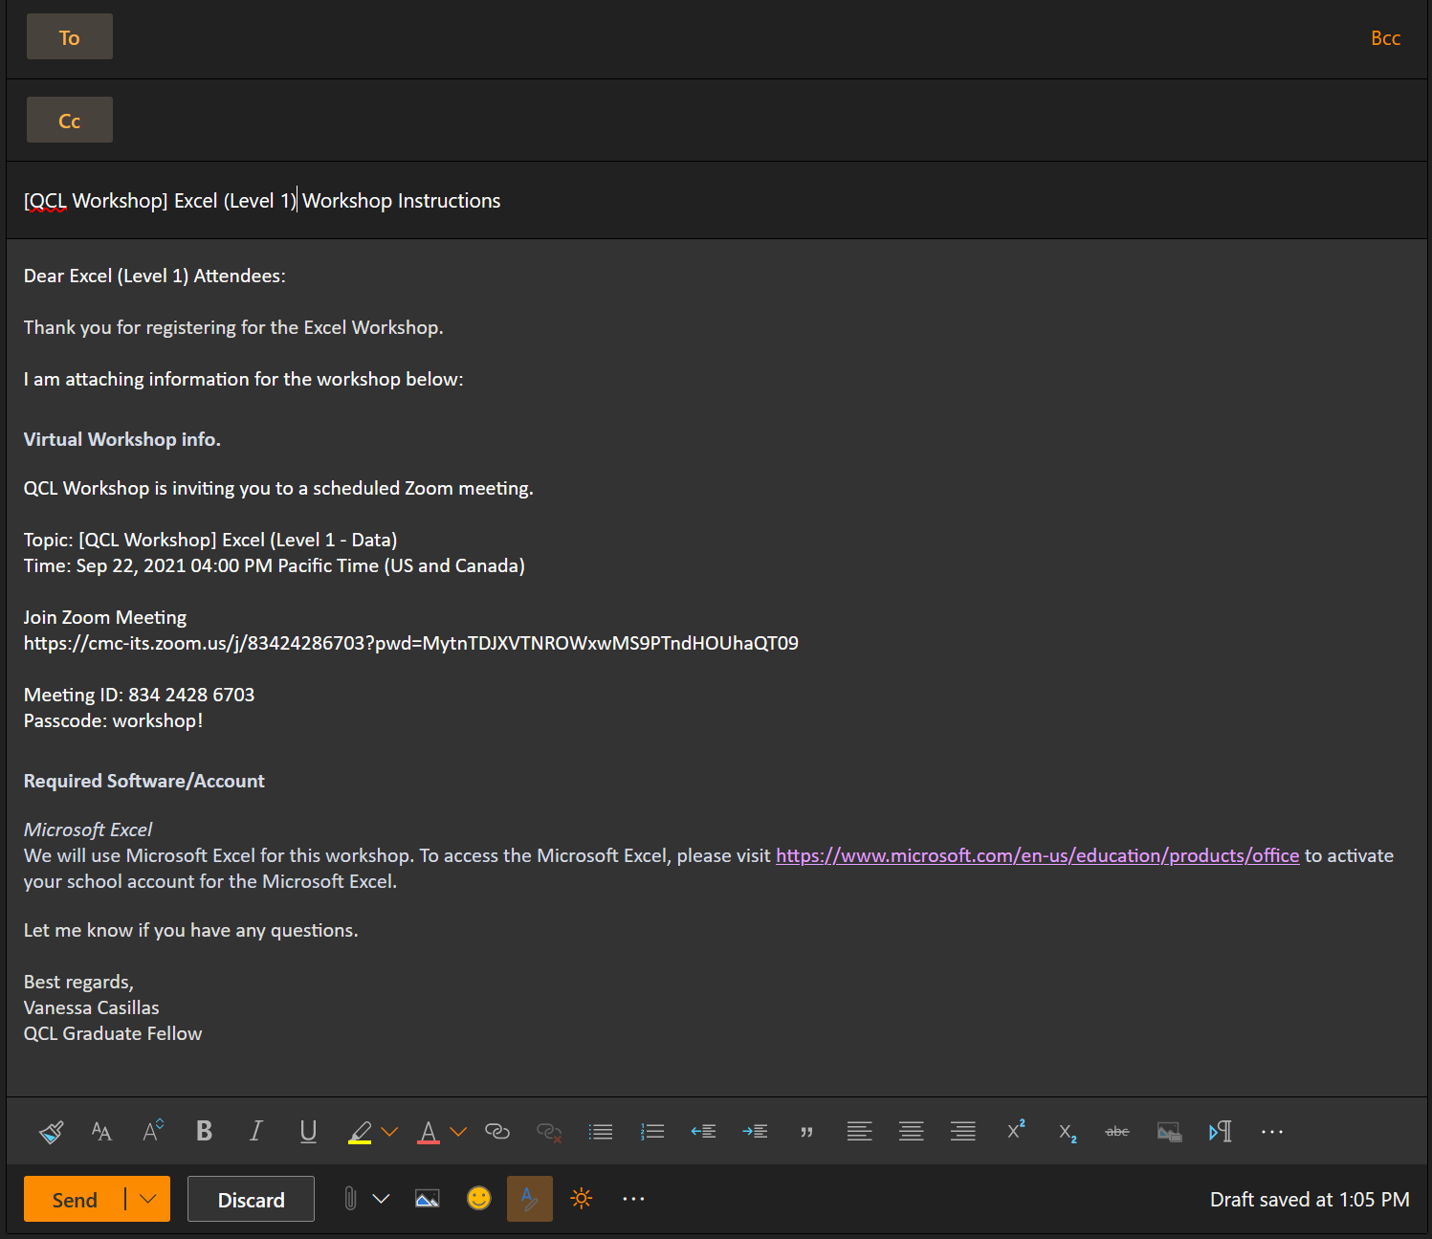

* + - * Example 2

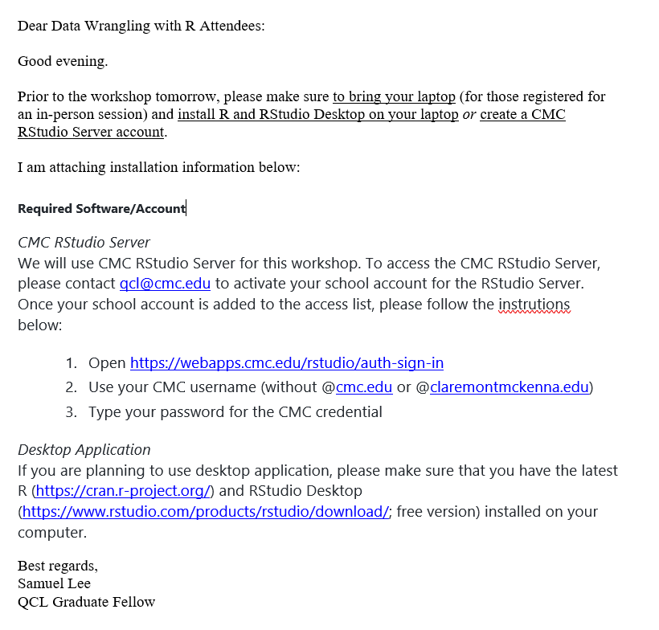

* + - * Example 3

­­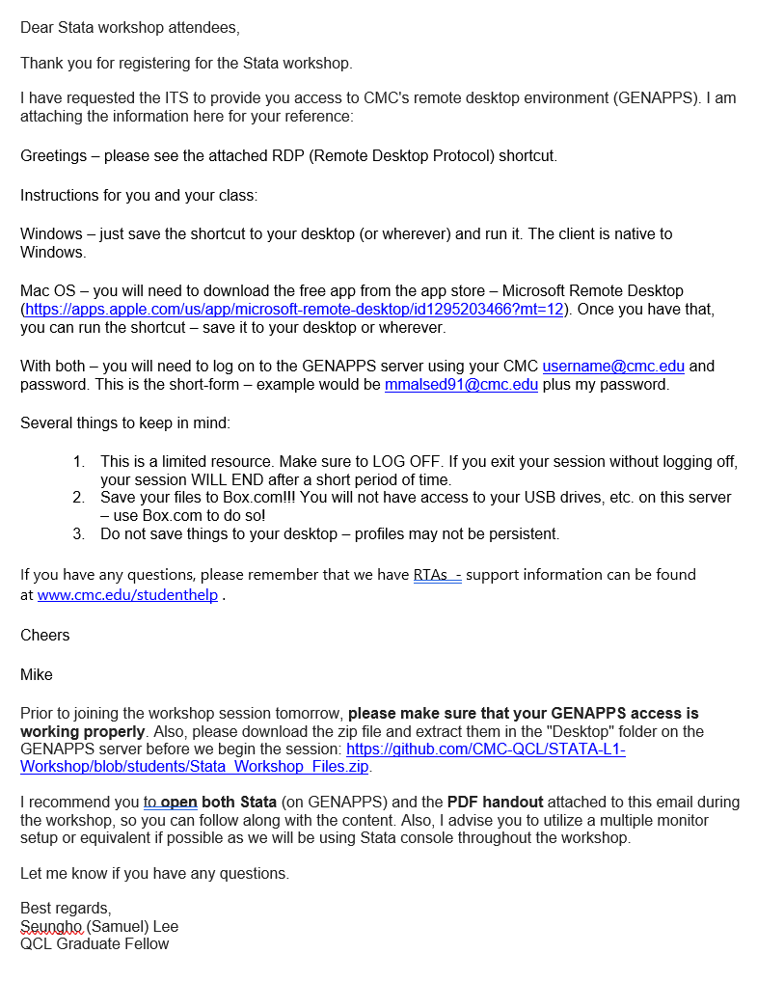

* Example 4

Dear **MATLAB (Level 1 – Coding+Computing)** Attendees:

Thank you for registering for the **MATLAB (Level 1 – Coding+Computing)** Workshop.

**# Getting Equipped with MATLAB (Level 1 – Coding+Computing)**

**Instructor:** Bhaven Mistry (Assistant Director of the QCL)

**## Summary**

Want to learn to program, but don’t know where to start or what to install? MATLAB is a numerical computing language and environment that is surprisingly easy to use. Typically used by engineers and scientists, you can think of it as a very powerful, customizable calculator. But, interestingly, it’s this very characteristic that makes MATLAB an ideal language for programming beginners, even if you’re not mathematically inclined.

In this workshop, we will step you through the basics of programming using the MATLAB coding environment. We will start by getting familiar with the software, learning the basics of variable assignment and manipulation, writing our own functions, and exploring some applications. If you’re completely new to programming, learning the fundamentals with MATLAB first is a great way to springboard into other languages. Alternatively, if you have some experience with programming, but have always wanted to learn what MATLAB is used for, this could be a good way to get your feet wet.

**### Pre-requisites:**

Internet Use: Introductory level (search, log-in, navigation of websites, etc.)

Software: Attendees are asked to have MATLAB on their computers for the workshop. MATLAB is available for CMC students and faculty at <https://www.cmc.edu/information-technology/academic-software>

**## Location**

Online (Attendees will receive the Zoom meeting information after registration)

**## Participants**

Open to all CMC Students, Faculty and Staff

I am attaching information for the workshop below:

QCL Workshop is inviting you to a scheduled Zoom meeting.

Topic: [QCL Workshop] Get Equipped with MATLAB

Time: Sep 29, 2021 03:00 PM Pacific Time (US and Canada)

Join Zoom Meeting

https://cmc-its.zoom.us/j/83773547610?pwd=Y2loa3VoWnQvWFQxUDg1V0xIbHBNdz09

Meeting ID: 837 7354 7610

Passcode: workshop!

Required Software/Account

<https://www.cmc.edu/information-technology/academic-software>

Let me know if you have any questions.

Best regards,

Vanessa Casillas

QCL Graduate Fellow

#### Attendees Emails

* + Go to Localist and click on event

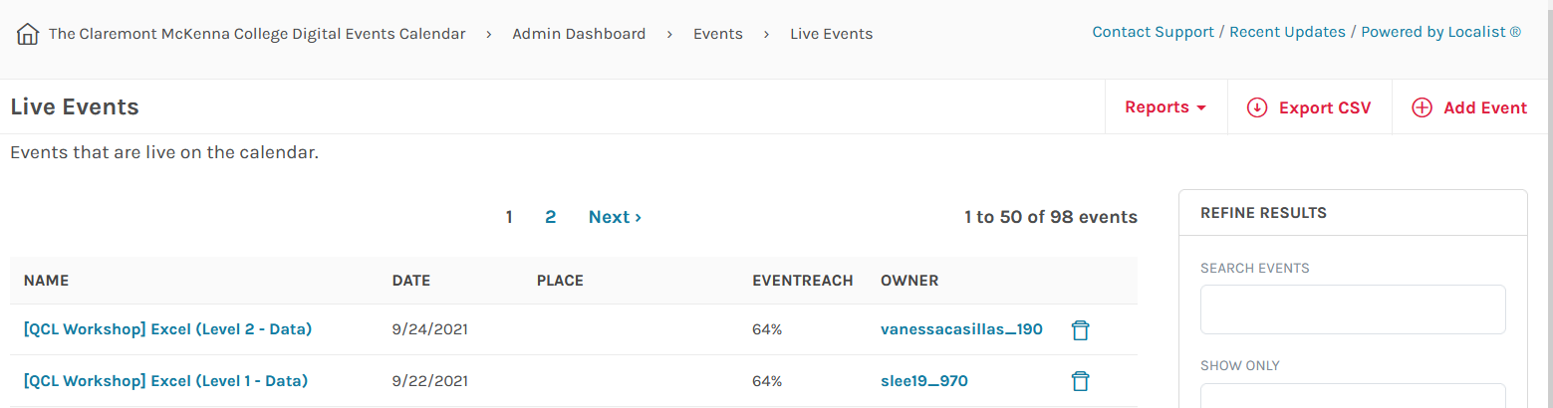

* + Click on View Confirmed Tickets

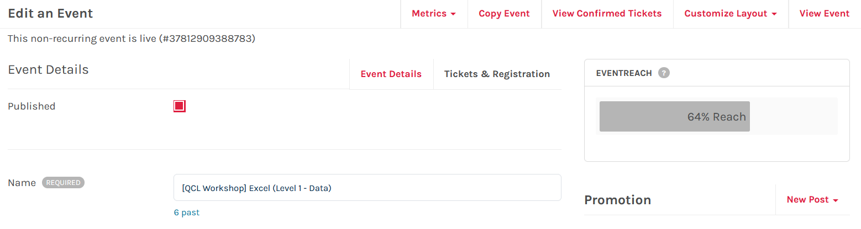

* + Click Export CSV

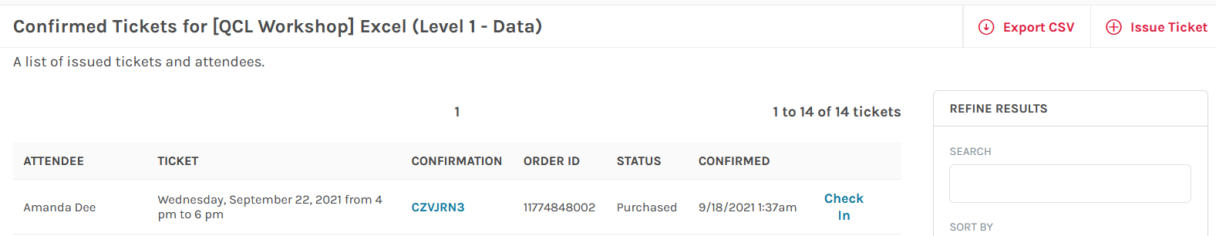

* + Go to email and download the CSV

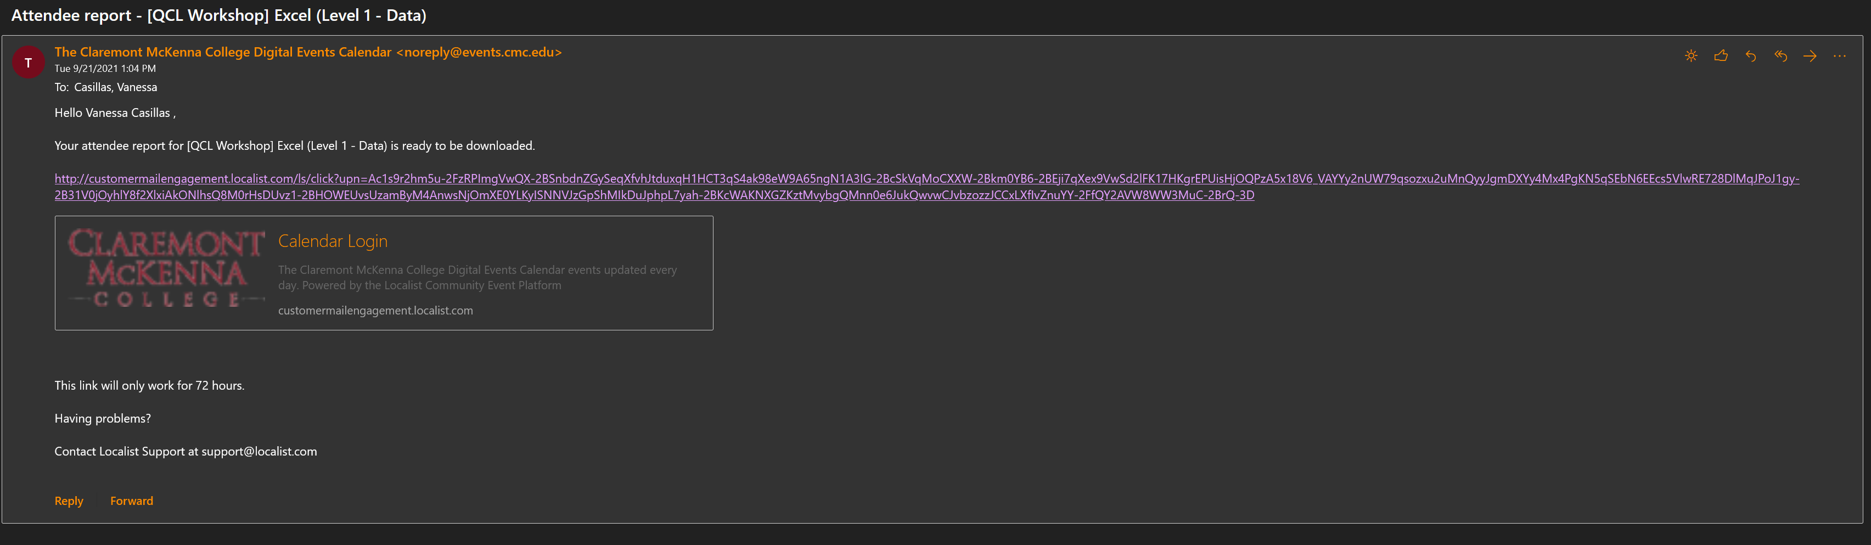

* + Open CSV and copy emails into your reminder email



### Day of workshop

#### Moderator checklist

* Morning of
  + Paste Zoom info in QCL Workshop – Workshop Control Booth chat in Teams
  + Send out reminders if you haven’t already
* Show up 30 minutes before workshop
  + Print out flyers
    - Put on tables where the attendees will sit
  + Log into Zoom (workshops)
    - Start 30 minutes before
    - Check audio and video
    - Make Instructor co-host
    - Test runs with instructor
  + Get shorten links from bit.ly ready
  + Set-up camera
  + Put the spotlight on workshop video feed
  + Make sure the instructor is screensharing
* Time of the workshop
  + Welcome everyone: (change when necessary for only virtual or only in person workshops)
    - Welcome to the QCL! Today’s workshop is (name of event) instructed by (name of instructor. My name is (your name) and I (as well as (other moderator)) will your moderators for today’s workshop. If you have any questions or concerns throughout the session, please write in chat for our virtual attendees or raise or have for our in-person attendees. Before we start, please make sure to sign in with either the QR code or the link provided. Lastly, this workshop will be recorded. Enjoy!
  + Link sign-in survey in chat and links for workshop from instructor

**Welcome! Please sign-in:** [**https://bit.ly/3zDNzPj**](https://bit.ly/3zDNzPj)

Link from instructor: <https://github.com/CMC-QCL/Excel-L2-Workshop>

If you have any questions or concerns throughout the session, please write in chat @everyone.

Thank you! Please sign-out: <https://bit.ly/3EIOgdX>

* + Click Record
    - Note: if on break, click pause not stop, we want the least number of files made
  + Check in attendees who attend on Localist
    - Cross check over Qualtrics to make sure that attendees take survey as well
  + Interrupt the instructor if an attendee online has a question or if the attendee in-person has not been seen raising their hand.
* End of workshop
  + Link Exit survey in chat
  + Thank everyone for coming
  + Clean up and back up
* Send email reminder if there is a low rate for surveys
* Send zoom meeting recordings to attendees that attended
  + Note: after every semester we dump recordings into a box file, before CMC does it

### Day after workshop

#### Qualtrics

* Give “Collaborate” to instructor on surveys

#### Zoom Recordings

* Only provided to the attendees that showed up for the workshop
* Records are ready to send the next day after the workshop

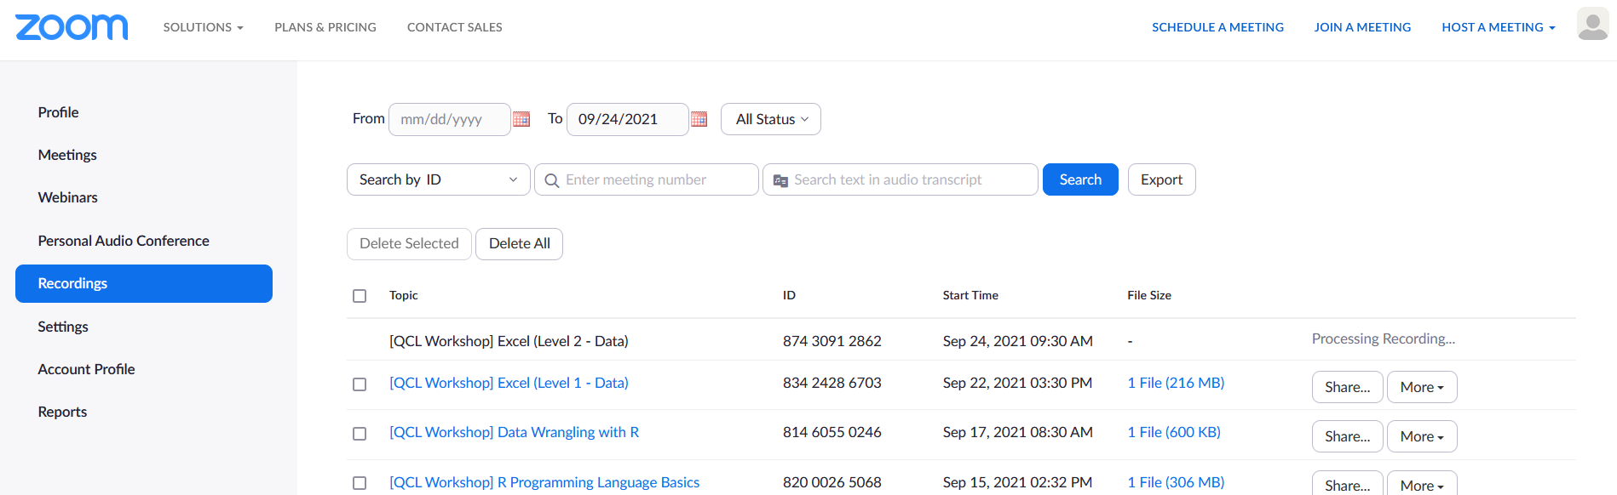

#### Ending email example

Subject: Thank you for attending the (name of workshop) Workshop

Hello (name of workshop) attendees,

Thank you for attending the workshop.

I have provided the links for sign-in and sign-out:

Sign-in:

(Link of survey)

Sign-out:

(Link of survey)

Please make sure to complete the surveys, they count as your attendance. If you have already completed them, thank you.

(all pasted from zoom)

Note: records are only provided if you attend the workshop

Lastly, if there was any homework assigned for this workshop, please send all documents to: qcl@cmc.edu for grading.

Thank you,

(your name)

QCL Graduate Fellow

### Workshop Issues

#### New attendees after closed registration

* Email to student for information: (Do not to ask for people’s gender for the new attendee’s emails as it is optional on our form.)

Subject: [QCL] Online Workshop on name (date at time) and name (date at time)

[Bcc'd everyone else except QCL Fellows]

Hi (name of new attendee),

Would you like to register for both Excel 1 and Excel 2 sessions?

Also, are you able to provide me following information?

1.      Please enter your student ID # (Must be 8 characters). For all faculty/staff/non-Claremont Colleges person, please insert 00000000.

2.      ~~Gender~~

3.      Are you a Freshman, Sophomore, Junior, Senior, Graduate Student, Faculty, Staff or Other?

Please note that we usually close registration 1 to 3 days prior (depending on the preparation needed to set up a working environment) to workshop events.

Best regards,

QCL Graduate Fellow (put your name here)

* Issue Ticket tab on Confirmed Tickets page

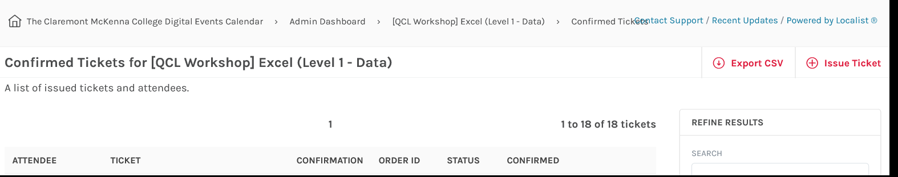

* Fill in all info

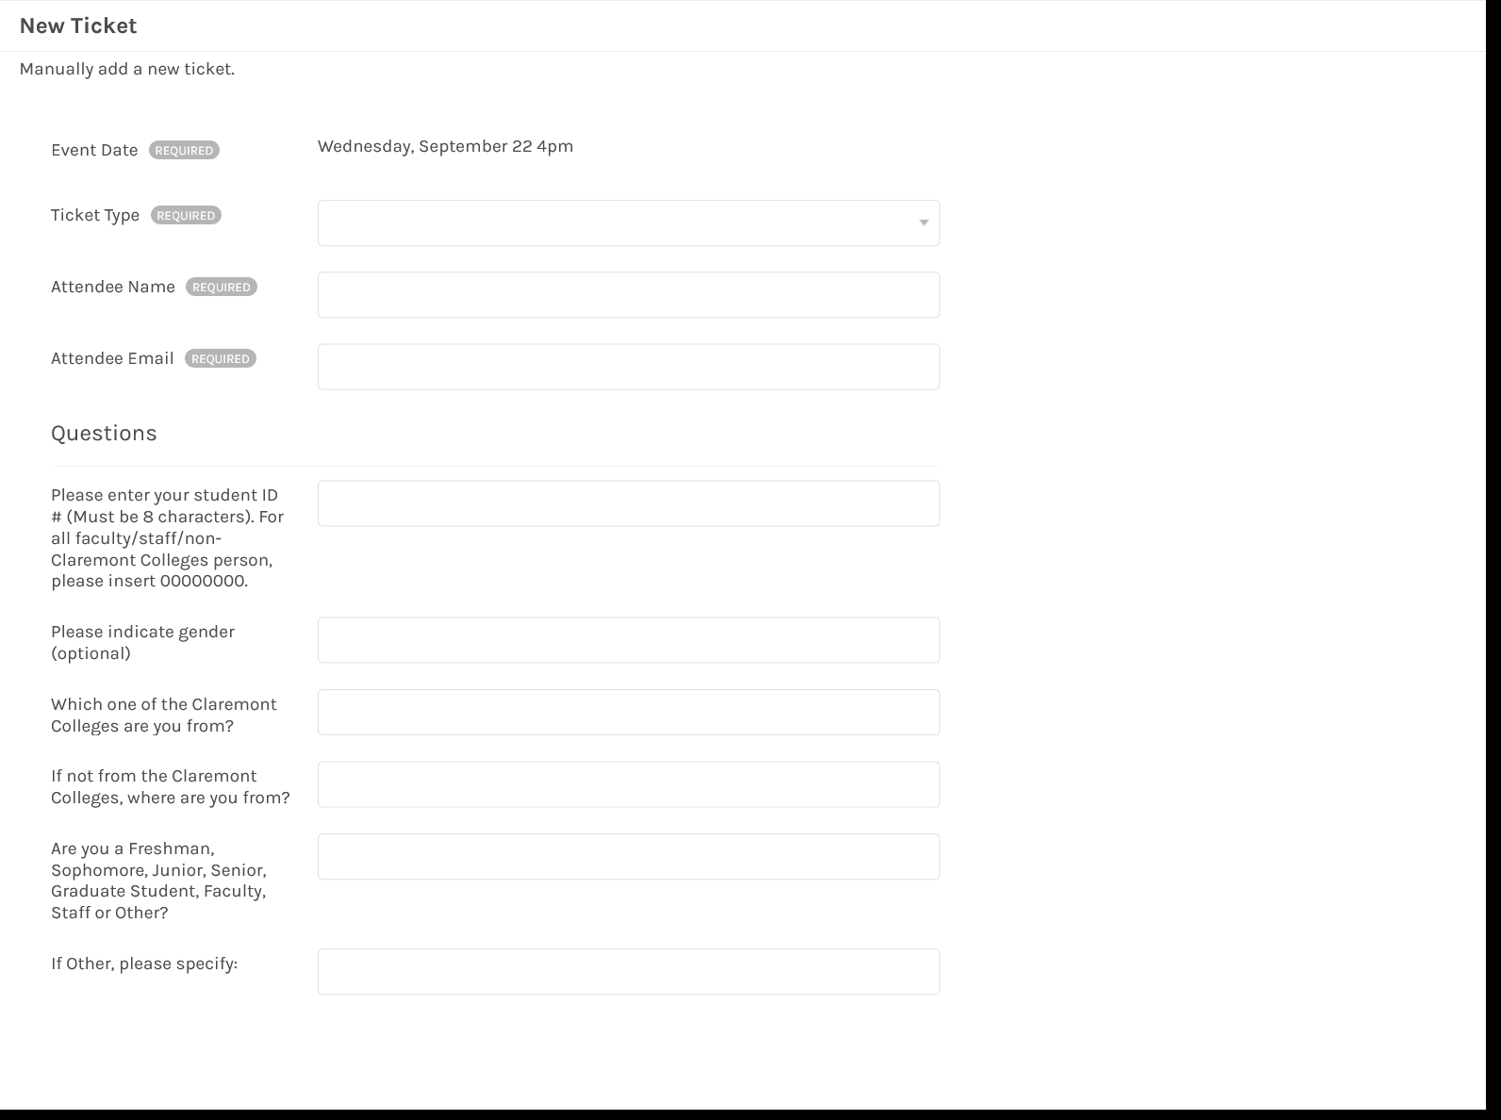

* Note: We typically have 15 seats but wait list is 5
* After filling out the form, the attendee will get an email from Localist
  + - Send out an email follow up to the new attendee

Subject: [QCL Workshop] Name of workshop – Availability

Hi (name of new attendee),

I have input your information into Localist for the (name of workshop) workshop.

You should have received a Localist ticket by now.

Please let me know if you have any questions.

Best regards,

QCL Graduate Fellow (put your name here)

* If you just input, the new attendee without information, send this email

Subject: [QCL Workshop] Name of workshop – Availability

Hi (name of new attendee),

I just received a message from Janna that you would like to register for the (name of workshop) workshop.

You should have received a Localist ticket by now.

Please let me know if you have any questions.

Best regards,

QCL Graduate Fellow (put your name here)

#### Check attendee’s emails

* Fix emails, sometimes they misspell their emails

### Building a Workshop

##### Example of workshop Template #1

Data Visualization with Tableau for Beginners

**Workshop Syllabus**

**QCL Literacy: L1-Coding**

Instructor: Zeyad Kelani, Grad Fellow of the Quantitative and Computing Lab at Claremont McKenna College

* **Summary**

Tableau is the most powerful, secure, and flexible end-to-end analytics platform for your data. It is designed for the individual, but scaled for the enterprise, Tableau is the only business intelligence platform that turns your data into insights that drive action.

* **tableau public gallery:**

<https://public.tableau.com/en-us/gallery/analyzing-ums?gallery=votd>

* **Target Audience**

This workshop is designed for beginners in data visualization. No prior programming knowledge is needed.

* **Required Software/Account**
* Tableau offers one-year Tableau licenses to faculty and students at accredited academic institutions.
* Install Tableau

1. Public Version: <https://public.tableau.com/en-us/s/download>
2. Free Trial: <https://www.tableau.com/en-gb/products/trial>
3. Students Access: <https://www.tableau.com/academic/students>
4. Faculty Access: <https://www.tableau.com/academic/teaching>

* **Agenda**
* What is Tableau
* Tableau Desktop Workspace
* Tableau Data Connections
* Filtering Data
* Sorting and calculations
* Charts and graphs
* Sharing and exporting
* **Before you start:**
* **Tableau Desktop application** is available on your PC.
* **Download Datasets** for Hands-On exercise
* **Datasets**

http://bit.ly/qcl-tableau-Level1-data

* **Data**:
  + The sinking of the RMS Titanic is one of the most infamous shipwrecks in history. On April 15, 1912, during her maiden voyage, the Titanic sank after colliding with an iceberg, killing 1502 out of 2224 passengers and crew. This sensational tragedy shocked the international community and led to better safety regulations for ships.
  + One of the reasons that the shipwreck led to such loss of life was that there were not enough lifeboats for the passengers and crew. Although there was some element of luck involved in surviving the sinking, some groups of people were more likely to survive than others, such as women, children, and the upper-class.

We use data offered through a Kaggle competition: <https://www.kaggle.com/c/titanic/data>

### Buying a ticket – Making sure it works

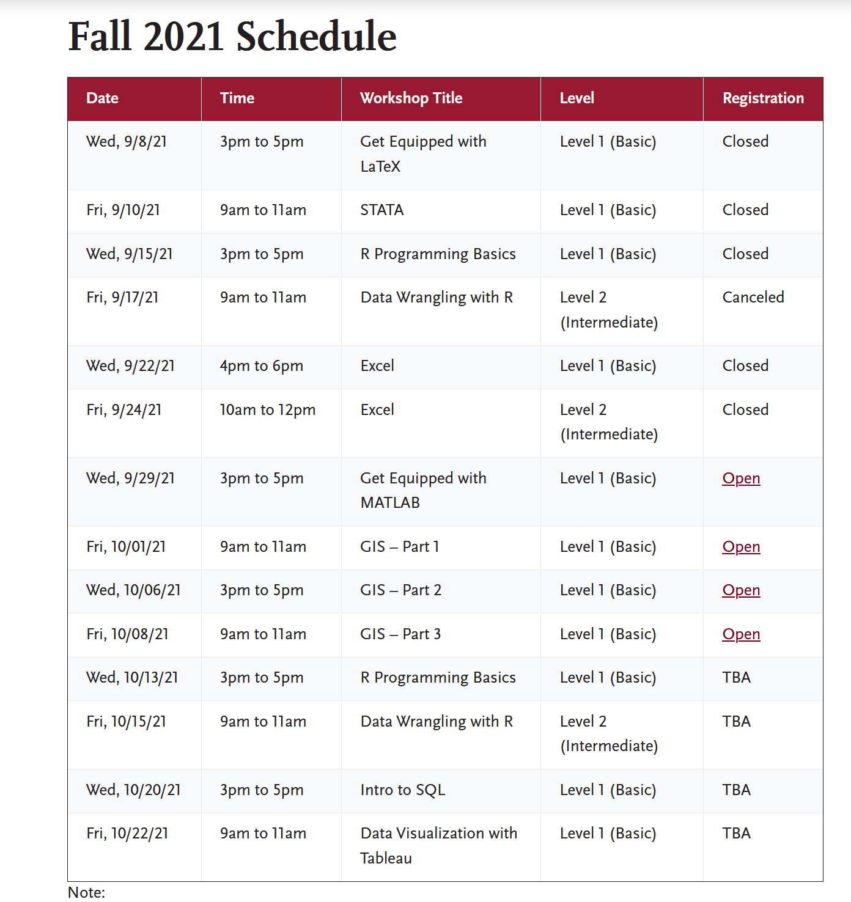

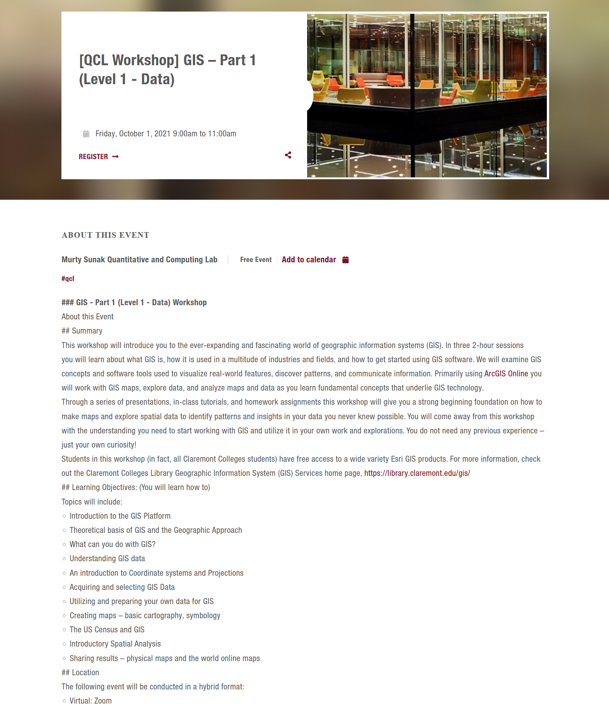

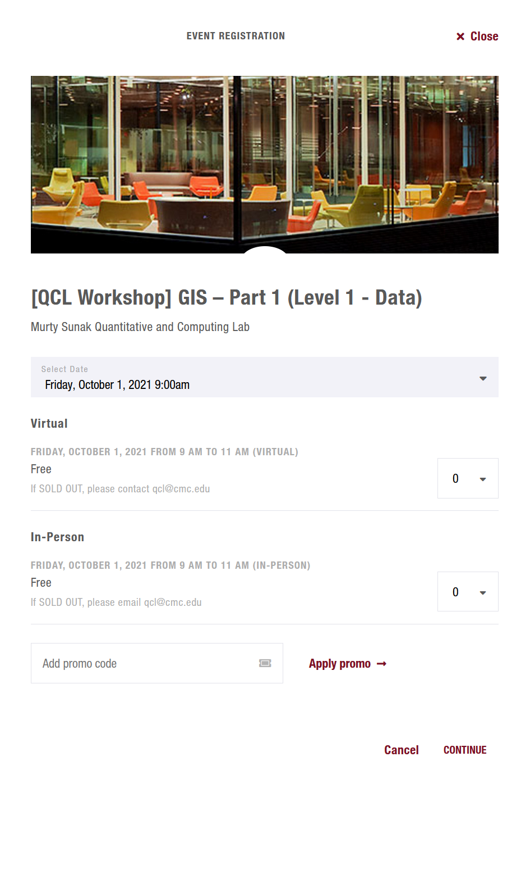 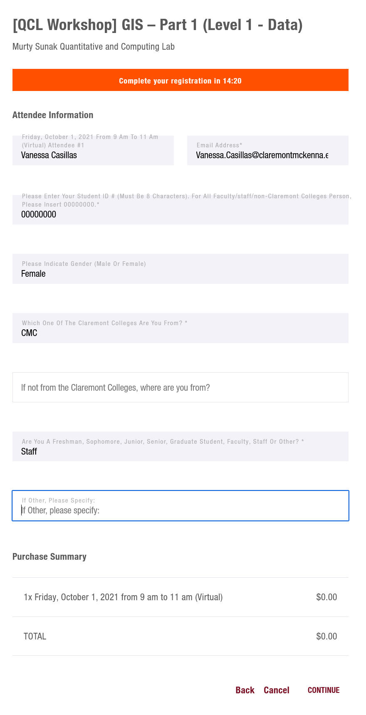

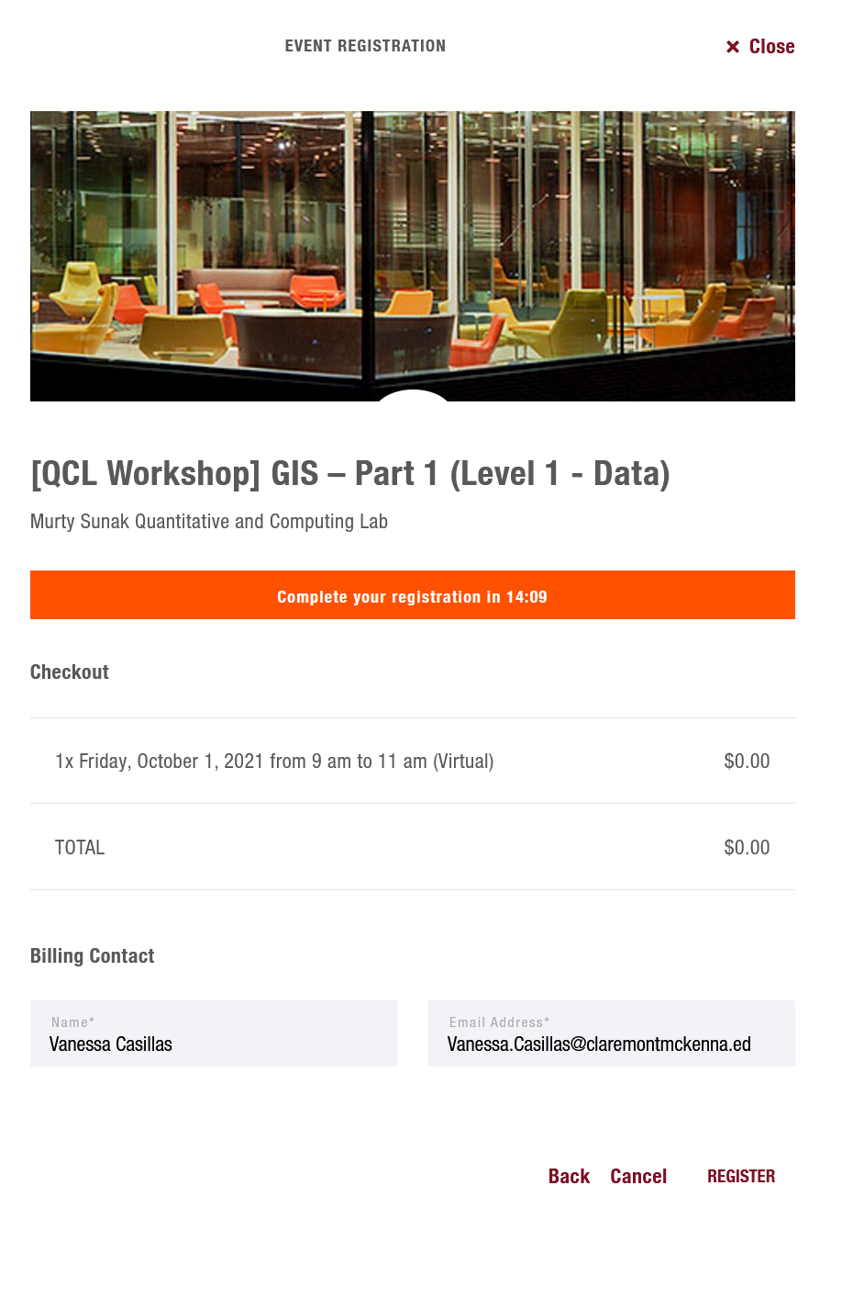

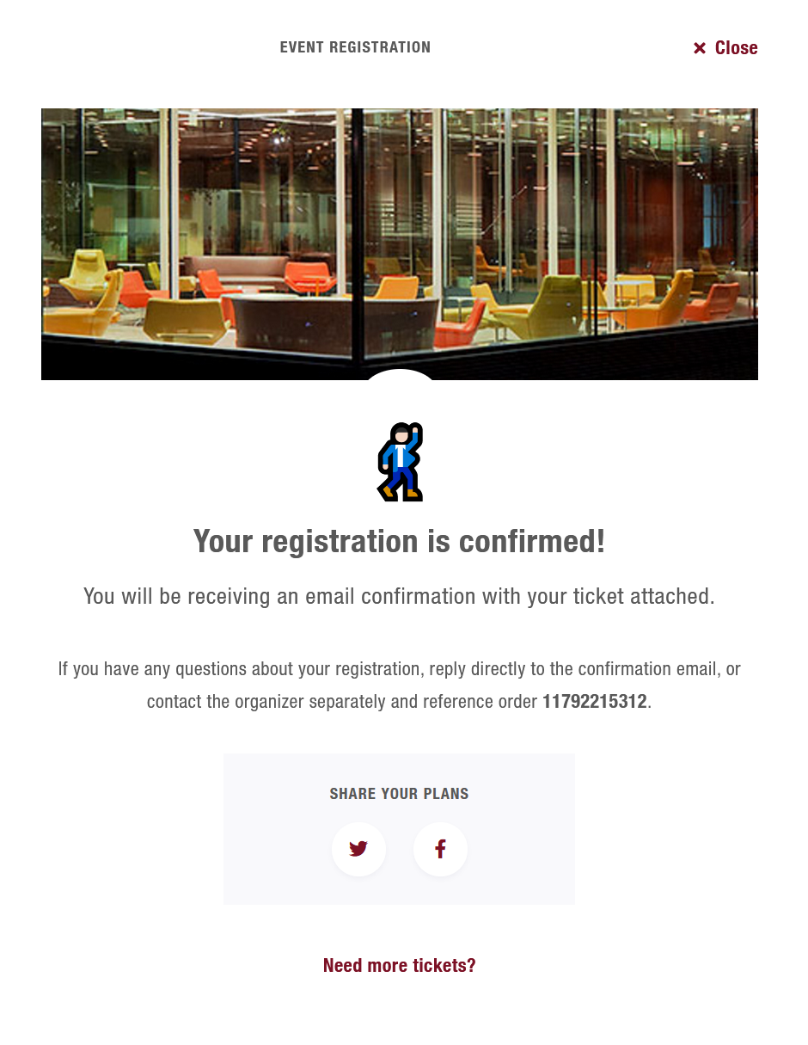

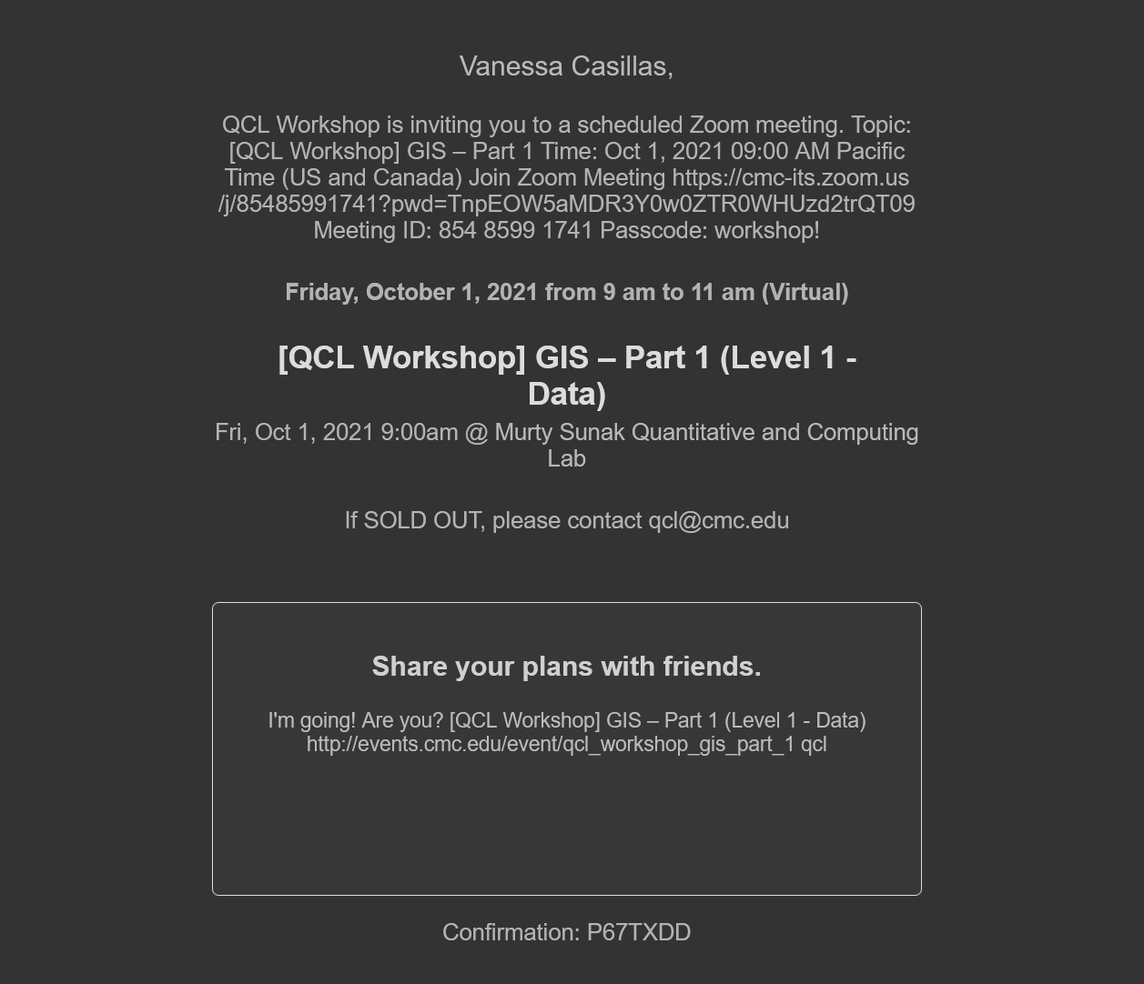

### Changing Website

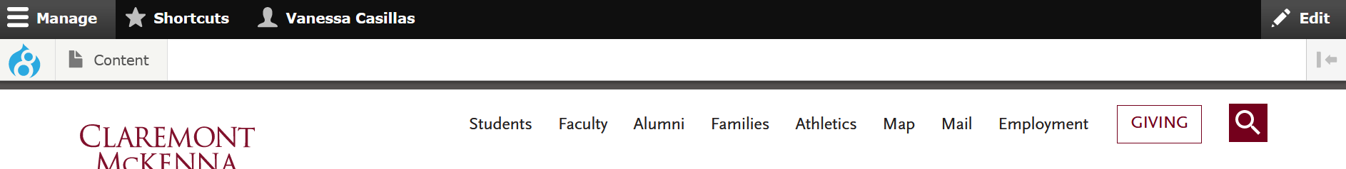

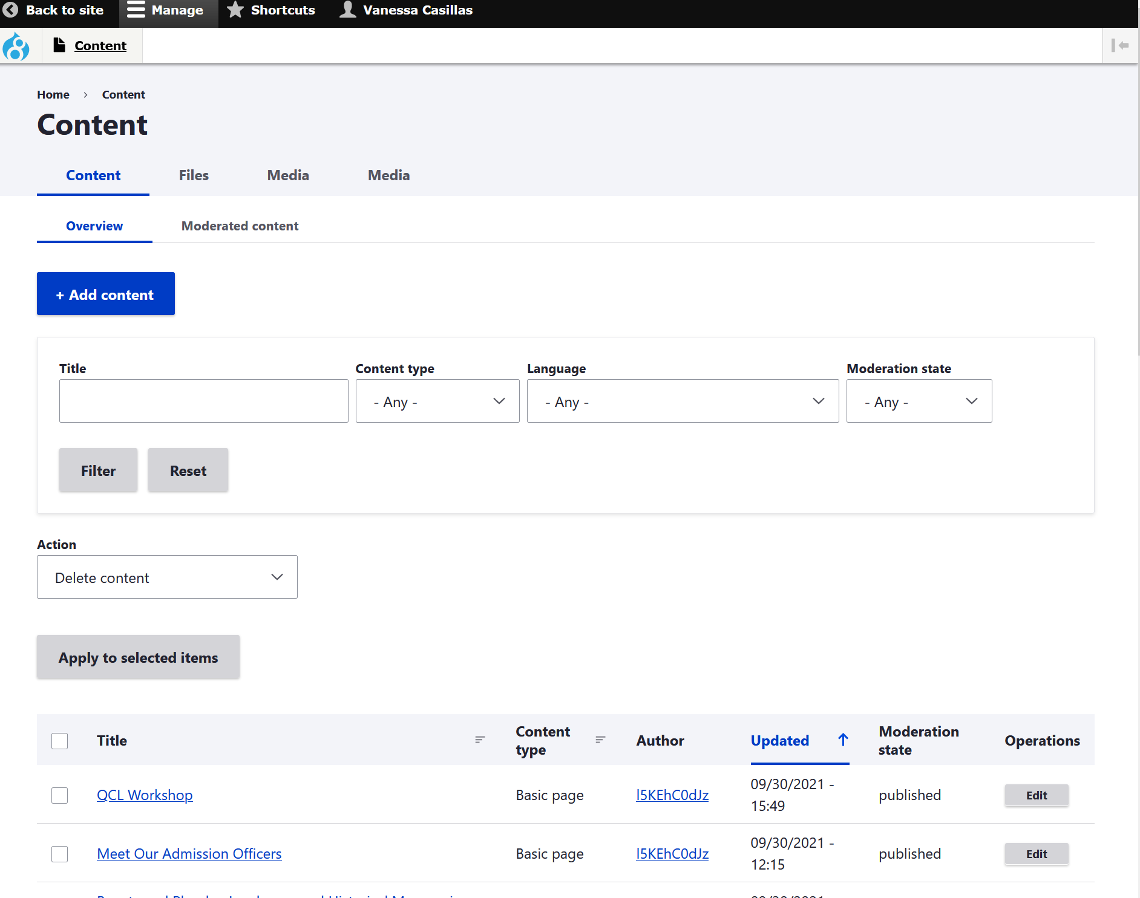

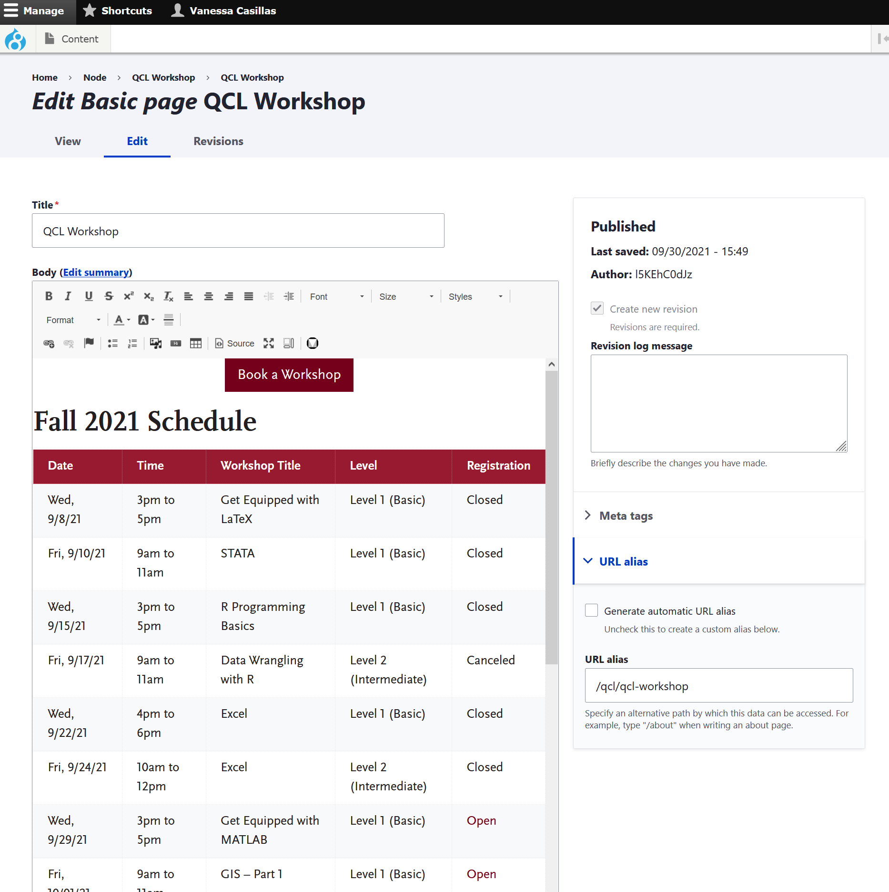

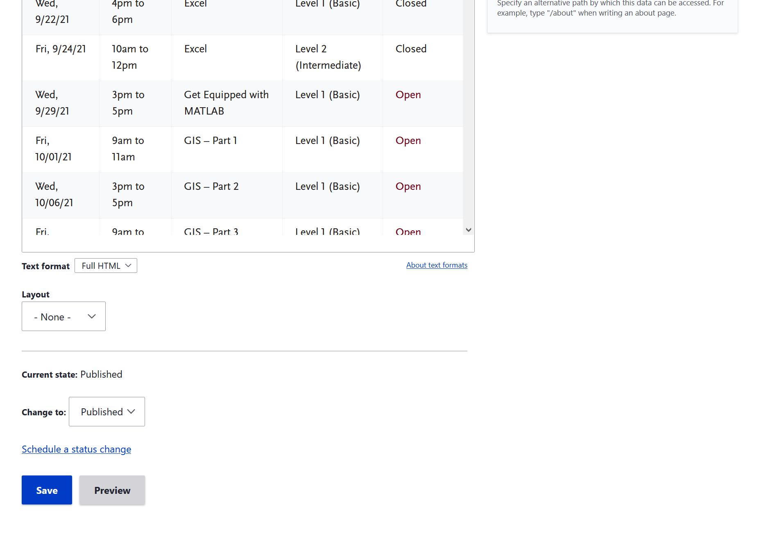

### Checklist for a Typical Workday

This is if there is no workshop or appointment going on

* Check email
  + Write back to anyone
* Two weeks prior work
  + Check what is coming in two weeks
    - Set appointments to meet with instructors
      * Get summaries
      * Tools
      * Point points
      * files
    - Licenses
* One week before work
  + Localist and zoom
  + Let Dr. Park know they are ready to be announced
* Two days before work
  + Send out reminder emails
  + Check and close the attendees
  + Get licenses
* Day of workshop
  + Look at workshop tasks
* Update QCL website
* Graphic Design
* Make workshops
  + SQL
  + EXCEL
  + GIS
* Workday
  + Put in schedule

### Workshops Building

* In the past, the way we offer our workshop to specific institute like Lowe was that we (Cindy) worked with their admin or student leader to find good times for their fellows and RAs and offer a separate workshop(s) for them. I am thinking we would want to offer them a separate GIS workshop(s).

1. Note: Should I add welcome, dress code and needed materials page?
2. Issues: contact another Graduate Fellow or IT ([help@cmc.edu](mailto:help@cmc.edu))
3. Firefox: bookmark websites